


A European infrastructure
for farmed animal genotype to phenotype research

Deliverable 6.1:
Inventory of upcoming technologies and required inter- and transdisciplinary networks bridging the gap between genome/cellular/organoid and organism level information with respect to key challenges as outlined in the Green Deal and Farm to Fork strategy
Grant agreement no°: 101094718
Due submission date
2025-April-30
Actual submission date
2025-April-29

Responsible author(s):
Eduard Murani (FBN)
Elisabetta Giuffra (INRAE)

Confidential: No

This project has received funding from the European Union’s Horizon Europe research and innovation programme under grant agreement No 101094718. The content of this report reflects only the author’s view. The European Commission is not responsible for any use that may be made of the information it contains.

DOCUMENT CONTROL SHEET
Deliverable name | Inventory of upcoming technologies and required inter- and transdisciplinary networks bridging the gap between genome/cellular/organoid and organism level information with respect to key challenges as outlined in the Green Deal and Farm to Fork strategy
Deliverable number | Deliverable 6.1
Partners providing input to this Deliverable | FBN, INRAE, NMBU
Draft final version  circulated by lead party to:  On date | ?
Approved by (on date) | ¿
Work package no | 6
Dissemination level | ?

REVISION HISTORY
Version number | Version date | Document name | Lead partner
Vs1 | 22.04.2025 | EuroFAANG_D6.1_v1 | FBN
Vs2 | 28.04.2025 | EuroFAANG_D6.1_v2 | FBN (After feedback from INRAE, NMBU and UEDIN)
Vs3 | 28.04.2025 | EuroFAANG_D6.1_v3 | FBN (After feedback from INRAE and UEDIN)
Vs4
Vs5

Changes with respect to the DoA (Description of Action)
None
Dissemination and uptake

Table of Contents

1. Executive Summary 4
2. Introduction and overview of activities 5
3. Overview of activities and outcomes of collaborative efforts towards building an inventory of critical needs for bridging the gap between in vitro and in vivo G2P research 7
3.1 Workshop “Bridging the Gap Between In Vitro and In Vivo G2P Research” 7
3.1.1 Foundational meeting 7
3.1.2 Workshop concept 7
3.1.3 Workshop outcomes: Current status, future goals, and pathways forward for the application of in vitro models in G2P research toward transferability to in vivo 8
3.2 The workshop “G2P in a Dish” (lead: WP4) 10
3.2.1 Workshop outcomes: Defining the paths to bridge the gap 10
3.3 Webinar “Bridging the Gap: Decoding Cell Talk In Vivo to Build Better In Vitro Models” 12
3.4 Survey gathering input for an inventory of key assets to bridge the gap between in vitro and in vivo G2P research 12
3.4.1 Profile of the respondents 13
3.4.2 Survey insights on available and required assets for the inventory 14
3.5 Conclusions and Next Steps 17
4. Annex 19
4.1 Whiteboards capturing ideas that emerged during the workshop discussions 19
4.2 Agenda of the G2P In a Dish workshop (3rd-7th February 2025, Jouy-en-Josas, France) 22
4.3 Updated survey form 28

Executive Summary
Background | Besides contributing to the 3R principles in animal research, in vitro G2P research complements in vivo G2P research in many important aspects. In vitro models not only avoid ethical concerns, such as stressful perturbations to animals during procedures like immune challenges (highly relevant to the Farm-to-Fork strategy), but also, due to their well-controlled conditions, allow researchers to address biologically targeted questions that are difficult to tackle at the whole-organism level. However, these differences between cellular in vitro and organismal in vivo environments also represent the main hurdle in translating findings across the two systems. EuroFAANG RI seeks to promote the use of cellular models for G2P research, aiming to strengthen the connection between these two approaches and provide solutions to bridge the existing gap.
Objectives | The objective of this task was to identify key challenges and to develop an inventory of solutions to bridge the gap between G2P research conducted at the cellular level in vitro and at the organismal level in vivo
Methods | To develop the inventory, we engaged with the community through a dedicated workshop, roundtable discussions during the "G2P in a Dish" workshop organized by WP4, and a targeted survey. In addition, we host a webinar featuring a world-leading expert in cellular genetics to explore novel approaches.
Results  & implications | Bridging the in vitro–in vivo gap remains a significant challenge that currently lacks coordinated efforts. Nevertheless, the inputs gathered through these activities enabled us to establish a strategic inventory of actions to guide stepwise progress, shaped by the current technological landscape. The main elements of the inventory include the continued development of in vitro cellular models, particularly of advanced systems that are still in the early stages of application in farm animal research, and the creation and dissemination of standardized protocols. A broader adoption of single-cell omics across the community is also crucial, as it is essential for gaining a deeper understanding of in vivo biology, useful for deconvoluting complex organismal phenotypes into cellular processes, and guiding the development of corresponding cellular models and functional assays. These efforts must be actively pursued and carefully coordinated, which will be a future focus of the EuroFAANG RI.

Introduction and overview of activities
The EuroFAANG Research Infrastructure (RI) project, funded by the EU Horizon Europe program (HORIZON-INFRA-2022-DEV-01), aims to develop a pan-European infrastructure to support genotype-to-phenotype (G2P) research in terrestrial and aquatic farmed animals. Coordinated by six leading European centers of excellence in animal science and genomics, the consortium will design the concept for a sustainable infrastructure that provides access to critical resources such as genomic and phenotypic data, biobanks of reference samples, in vitro cellular models, and genome editing technologies. The EuroFAANG RI also aims to deliver world-leading expertise, shared research facilities, and targeted training programs to build the next generation of farmed animal scientists. By connecting national capacities and linking with existing European infrastructures, EuroFAANG RI will strengthen the research ecosystem, close key gaps identified by the ESFRI Roadmap, and promote sustainable innovation in animal agriculture.

The EuroFAANG RI is strategically aligned with the Farm to Fork strategy. The ‘F2F strategy’ is at the heart of the Green Deal and comprehensively addresses the challenges of sustainable food systems and recognises the links between food, healthy societies and a healthy planet. As such the resources for farmed animal science provided by the EuroFAANG RI are relevant to “environmental impacts as well as the optimisation of resource use”.

WP6 aims to expand capabilities with new technologies in phenotyping and genomics, and to engage with stakeholders to promote the uptake of new tools and concepts thereby advancing the breeding and management of farmed animals across Europe.

Linking genotype to phenotype in cellular systems such as cells or organoids can provide a useful complementary approach to the use of whole organisms in G2P research, minimising the use of live animals in research according to the 3R principles. Task 6.1 aims to develop strategies and resources to bridge the knowledge gap that currently exists between cell/organ- and organism-level information.

Bridging the in vitro – in vivo gap represents a difficult and continuously evolving challenge for contemporary G2P research. Parallel actions carried out by WP4 (Task 4.1, 4.2 and 4.3) aim to establish a European biobanking framework to share resources of tissues and cells, including genome edited cell lines, and to establish a durable network enabling scientists to maximise the use of in vitro cellular models in G2P research. Task 5.1 of WP5 aims to provide a route to application of FAANG data in vitro by creating a framework for access to high throughput phenotyping (HTP) platforms for the validation of candidate causal variants. The activities of Task 6.1, summarized in this deliverable, were carried out in close collaboration with WP4 and WP5 with the focus to put together the list of current technologies and the diversified approaches already taken or foreseen by current/future users of in vitro and in vivo technologies to overcome the in vitro – in vivo gap challenge.

To create the inventory based on input from the animal science community and leading external experts, we organized the following activities:
- A workshop (Section 3.1) and roundtable discussions (Section 3.2) to identify key challenges, explore possible solutions, and assess required resources.
- A webinar (Section 3.3) featuring a leading expert in cellular genetics who will present an innovative systems biology approach, offering a potential methodological blueprint and a foundation for discussing necessary resources.
- A community survey (Section 3.4) designed to broaden participation and gather additional opinions and ideas.

Overview of activities and outcomes of collaborative efforts towards building an inventory of critical needs for bridging the gap between in vitro and in vivo G2P research

3.1 Workshop “Bridging the Gap Between In Vitro and In Vivo G2P Research”

3.1.1 Foundational meeting
In order to prepare the agenda for the planned workshop, a foundational meeting of eight FBN scientists with expertise in G2P research, cell biology and in vitro models, and biomathematics was held on 5th January 2024. The team brainstormed on various topics related to the current state of in vitro cellular models in farm animals, methods to collect phenotypic data from these models and how to link the data to organismal phenotypes.

One of the major gaps that the participants identified was the lack of suitable in vitro models in farm animals. Advantages and limitations of stem-cell based in vitro models were discussed, and opportunities for adopting protocols from well-established model species as well as critical need for standardization highlighted.

The limitations of current models in accurately replicating the complexity of in vivo conditions were a central theme of the meeting. A key conclusion was the necessity for the research community to enhance in vitro models through a more comprehensive understanding of the corresponding in vivo biology. One proposed strategy to address this limitation involves conducting parallel in vivo and in vitro experiments using cells derived from the same individual, enabling direct comparison of cellular functions across physiological and artificial environments. To establish the link between cellular processes in vitro and in vivo in a G2P context, the use of deeply phenotyped reference populations was proposed.

At the meeting a core group was formed with responsibility to organize the subsequent workshop (see below) and develop the workshop agenda.

3.1.2 Workshop concept
To initiate a broad and inclusive dialogue, the core team compiled a list of 74 potential participants, encompassing researchers from diverse disciplines and species as well as stakeholders from animal breeding and biotech sectors. These invitees were asked to indicate their availability via an online poll. The most suitable date for the workshop was identified as 16th June 2024.
To maximize engagement, invitations were distributed both through EFFAB and via personal outreach. The invitation email included a brief introduction, a link to an accompanying survey (detailed in Section 3.2), and a warm invitation to collaborate. Ultimately, the workshop brought together 23 participants—primarily academic researchers, alongside a representative from the biotech sector.

The session opened with an overview of Work Package 6 (WP6), highlighting the motivation behind bridging the gap between in vitro and in vivo research in the context of advancing the 3R principles in animal experimentation. A basic concept that was proposed during the workshop involved a dual approach to narrowing this gap: advancing the development of physiological in vitro cellular models in farm animals such as organoids, while also deepening our understanding of cell function in vivo through cutting-edge single-cell omics technologies that can be used to enhance the fidelity of in vitro models.

The discussions in this workshop focused particularly on the in vitro dimension of this challenge, exploring both current and potential future applications of in vitro models in genotype-to-phenotype (G2P) research. To structure the exchange of ideas and explore practical next steps, participants were guided through a series of thematically connected questions. Throughout the workshop, participants elaborated on current applications of in vitro models in G2P research, identified key hurdles related to the transferability of findings from in vitro systems to in vivo contexts, and explored strategies to overcome them.

Participants were split into two breakout groups, using online whiteboards to capture and share their ideas collaboratively. All presentation materials and whiteboard outputs are provided in Annex 4.1.
Participants were also encouraged to further contribute their insights by completing the accompanying survey, helping to shape the future direction of this collaborative effort.

3.1.3 Workshop outcomes: Current status, future goals, and pathways forward for the application of in vitro models in G2P research toward transferability to in vivo

- Current applications of in vitro cellular models in G2P research in farm animals to support key objectives of the Green Deal and Farm to Fork strategies
Key examples discussed include:
- Dissecting the genetic architecture
  - Cryopreservation of genetic traits/resources using stem cells
  - Investigation of genotype-environment interactions e.g. using primary cells
  - Testing of candidate genes and candidate causal mutations using gene editing
- Unraveling trait biology
  - Modeling of digestion and absorption of nutrients using organoids, or 2D culture
  - Investigation of heat tolerance
  - Investigation of immune response and host-pathogen interactions
  - Understanding gene functions, trait expression, and defining molecular phenotypes for novel biomarkers
  - Genome-wide CRISPR screens
- Industry application
  - Product testing
Participants engaged in a lively discussion on whether a EuroFAANG RI should focus on specific traits and tissues, such as gut and liver for efficiency traits (in view of Green Deal and Farm-to-Fork strategy), or remain unrestricted by offering a broad, comprehensive service. A practical way forward that emerged from the discussion is to initially prioritize the development of the most in-demand models, while maintaining the long-term ambition of establishing a comprehensive service portfolio.
- Significant barriers and limitations in applying in vitro cellular models

During the discussion, participants identified several limitations associated with the application of in vitro models, some of which are general, while others are specific to particular models:

- Limited availability of cell culture models, including immortalized cell lines, with pronounced gaps in certain taxa such as avians or aquaculture species
- Difficulties to immortalize some cell types (such as myeloid cells)
- Occasional misidentification or incorrect assignment of cell type in existing cell lines
- Insufficient information about some cell lines
- Shortage of markers for verifying cell type identity
- Problems with genome instability in immortalized cell lines (e.g. ploidy)
- Organoids may lack cell types present in native tissue; for example immune cells are typically absent
- Technical barriers in using organoids, such as efficient sgRNA delivery
- Technological variation frequently exceeds biological variation
- The physiological state or environment of the donor animal may influence function of the cellular model, e.g. via epigenetic mechanisms
- Throughput could currently be a challenge with more advanced cellular models
- The complex biology linking external and molecular traits presents another challenge when attempting to connect in vitro and in vivo research
- Cellular models are currently not advanced enough to be attractive for industry, breeding companies

Participants expressed significant concerns about the transferability of findings from in vitro cellular models to in vivo systems. They emphasized the need for more research and for concept or case studies to demonstrate the utility of in vitro cellular models.

- Suggested solutions, and essential requirements
The workshop discussions identified several strategic directions and technical requirements to improve the utility and reliability of in vitro systems for genotype-to-phenotype research:
- Promote the systematic characterization and development of well-defined, immortalized cell lines
- Develop and implement autologous media components/serum, to reduce variability and better mimic in vivo environments
- Establish robust cell-type-specific markers - the expression of defined marker genes was proposed as a viable approach to enhance cellular identification
- Create publicly accessible databases providing expression profiles of different cell types
- Leverage advances in single-cell omics technologies to refine cellular models - for example, by determining the in vivo cellular composition of target organs to guide the development of accurate co-culture systems and organoid validation
- Encourage studies that bridge in vitro and in vivo systems through parallel experimental designs, thereby enabling direct comparison and validation of findings across contexts
- Expand the development of advanced in vitro systems beyond organoids, including three-dimensional cultures and organ-on-chip platforms

The workshop emphasized that working with cell models demands specialized expertise, and developing these skills is crucial. Standardized methods and protocols, enhanced services and networks, and improved data-sharing practices are essential for progress. Ongoing and proposed initiatives to improve cellular models must be well-coordinated to avoid duplication of efforts. It was concluded that a EuroFAANG RI would have the opportunity to take a leading role in coordinating and organizing these activities.

3.2 The workshop “G2P in a Dish” (lead: WP4)
The workshop “G2P in a Dish” (see MS11 and Annex 4.2) was organized by Work Package 4 (WP4) in collaboration with both WP5 and WP6. The event highlighted the critical role of in vitro models in advancing the implementation of the 3R principles in animal research. Trainers and invited speakers presented a range of applications of in vitro cellular models within the context of G2P research in farm animals. Two roundtable discussions were dedicated to addressing the key challenges associated with the application of in vitro models in G2P research in farm animals.

3.2.1 Workshop outcomes: Defining the paths to bridge the gap
Several relevant approaches emerged from the discussions concerning the need to fill the in vitro-in vivo gap. One notable example involved correlating the outcomes of nutritional studies using advanced intestinal in vitro models with in vivo feed trials in aquaculture (F. Gandolfi, Univ. Milan). An intriguing proposal was made to develop a Phenotype Outcome Pathway (POP) knowledge base for G2P research, modelled after the Adverse Outcome Pathway (AOP) framework established in toxicology (M. Whelan, JRC Ispra). Such a community-driven knowledge repository could guide in vitro modelling efforts and facilitate the identification and exploration of key events along the G2P causal chain.

During the second roundtable discussion (“In vitro vs. in vivo G2P research, which perspectives?”), participants identified major challenges in G2P research relevant to the aim of Task 6.1, including issues of reproducibility, standardization, and the translatability of in vitro findings to in vivo contexts. A central question raised concerned how the research community should balance efforts between simple or moderately complex cellular models—such as immortalized cell lines, primary cells or epithelial organoids—and more complex systems like complexified organoids and Organ-on-Chip technologies. It was widely acknowledged that, while complex models tend to offer higher physiological relevance, G2P research progress in this area must be built upon a thorough understanding of simpler and moderately complex systems. Immortalised cell lines can generate essential baseline data and provide scalable, cost-effective platforms for hypothesis generation, e.g. by CRISPR screens. Organoid systems, already widely used in humans and model animals for several applications, still require work for improving and scalability and results reproducibility, and the sharing of standards. Complex in vitro models are at their infancy in farmed animals, and so far are best suited for validation of very specific hypotheses and detailed mechanistic investigations.

A complementary, tiered approach was therefore discussed as the most effective strategy. By integrating in vitro systems of different complexity levels the G2P research community can enhance both biological accuracy and experimental efficiency. However, participants also recognized persistent knowledge gaps in fundamental biological processes, emphasizing the ongoing need for basic cell research.

To increase the physiological relevance of in vitro models, a multifaceted approach integrating in vivo, in vitro, and in silico methodologies was deemed essential. A critical component of this strategy involves the deep molecular characterization of in vitro systems and the systematic comparisons with their corresponding in vivo tissues. Such comparative analyses can inform computational modelling efforts, enabling simulations that capture the complexity of biological systems and predict outcomes. These predictions, in turn, can guide the design and optimization of in vitro experiments to more closely mimic in vivo conditions.

Importantly, molecular discrepancies identified through these analyses can be used to refine in vitro models via targeted interventions, such as gene editing or optimization of culture conditions in organoid systems. Nevertheless, participants acknowledged a major limitation: many traits relevant to initiatives like the Green Deal or Farm-to-Fork strategy are multifactorial and involve complex systemic interactions. As such, while the multifaceted approach holds significant promise, in vitro models are likely to remain complementary to in vivo studies for the foreseeable future.

3.3 Webinar “Bridging the Gap: Decoding Cell Talk In Vivo to Build Better In Vitro Models”
We have arranged a webinar that aims to build on ideas presented at the workshop “Bridging the Gap Between In Vitro and In Vivo G2P Research”. We have invited Dr. Roser Vento-Tormo from the Welcome Sanger Institute, a pioneer in developing tools for the analysis of cell–cell communication, particularly through the widely used tool CellPhoneDB (Figure 1).
Dr. Vento-Tormo will present her systems biology approach, which integrates single-cell and spatial transcriptomics, epigenetics, and cell imaging to generate comprehensive maps of human tissues. She will demonstrate how her team uses these maps to guide the development and improve the interpretability of in vitro models. Her work serves as both a case study and a methodological blueprint for how to achieve a deep understanding of in vivo biology to inform and refine cellular model development.
We aim to use this presentation as a starting point for a broader discussion on the tools and resources needed to apply similar approaches in farm animal research.
The webinar will take place on the 6th May 2025. The report will be updated with the outcomes of the discussion following the event.
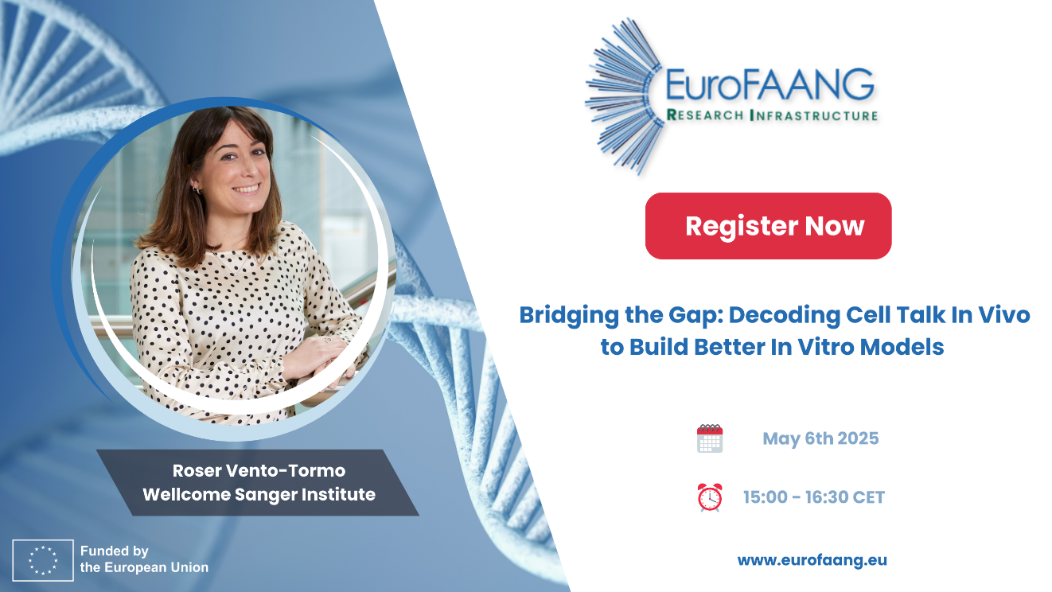
Figure 1: Promotional banner for the webinar, designed by EFFAB

3.4 Survey gathering input for an inventory of key assets to bridge the gap between in vitro and in vivo G2P research
To more comprehensively capture the current and emerging applications of in vitro cellular models, as well as efforts to connect these to in vivo research, the workshop discussions (section 3.1) were complemented by an online survey. Similar to the workshops, the survey participants were asked a series of thematically related questions. In order to gather novel insights, the survey did not include pre-formulated response options; instead, participants were invited to briefly describe their use of in vitro cellular models in G2P research, as well as their application of—or awareness of—emerging technologies and networks aimed at bridging the gap between in vitro and in vivo research. The survey was initially distributed alongside the workshop invitation (as described in section 3.1.2). It was later updated and disseminated in a second round to members of the WP4 think tank and lecturers involved in the "G2P in a Dish" workshop (Annex 4.3).

3.4.1 Profile of the respondents
By April 2025, 18 researchers from six EU countries had responded to the survey (Figure 2). The relatively modest participation likely reflects both the effort required to complete the open-ended questions and the fact that the topic remains challenging and not yet widely addressed within the broader research community. Notably, approximately 80% of respondents were senior scientists or principal investigators, indicating a high level of expertise among participants. This is also reflected in the breadth of their responses, which demonstrated extensive knowledge across diverse areas of G2P research (Figure 3). In terms of species coverage, the survey responses encompassed all major farm animal species (Figure 4), as well as commonly used model organisms (mainly rodents), highlighting the broad application of in vitro cellular models across different biological systems.
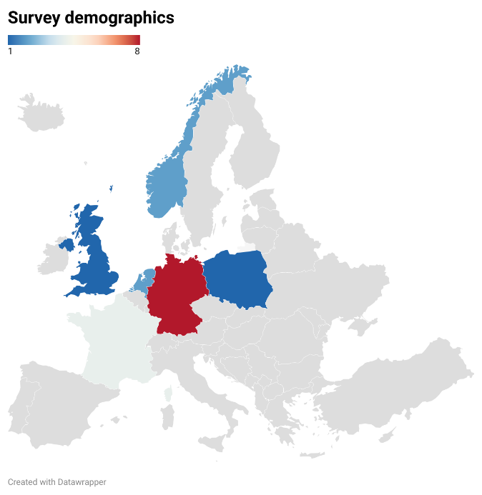
Figure 2: Geographical distribution of survey respondents.

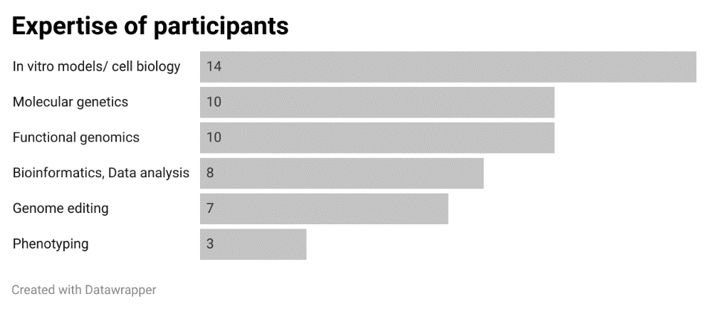
Figure 3: Expertise of participants.

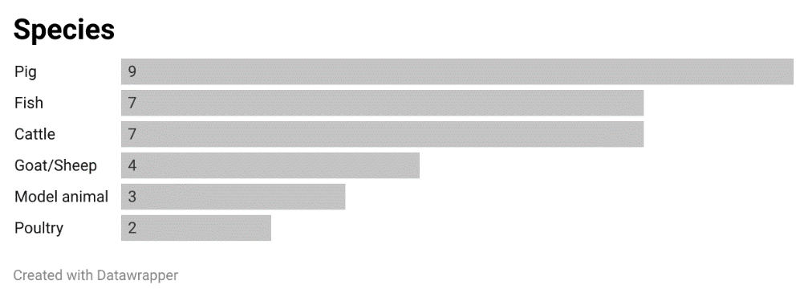
Figure 4: Representation of different species/species categories in the responses to the survey.

3.4.2 Survey insights on available and required assets for the inventory

3.4.2.1 Application of in vitro cellular models in G2P research
The survey responses revealed that participants primarily use in vitro cellular models to investigate the biology underlying relevant traits—particularly for identifying key genes involved in immune-related processes. Most respondents mostly rely on relatively simple models, such as primary cells or readily available homologous or heterologous immortalized cell lines. While participants demonstrated awareness of a wide range of more advanced in vitro models—including organoids, organ-on-chip technologies, complex co-culture systems, and induced pluripotent stem cells (iPSCs)—these approaches are not yet widely adopted. As illustrated in Figure 5, current applications remain limited and are largely focused on the use of moderately complex systems such as organoids or spheroids. The need to develop cell models derived from diverse breeds was also highlighted, underscoring a gap in current model availability and a potential area for future development.

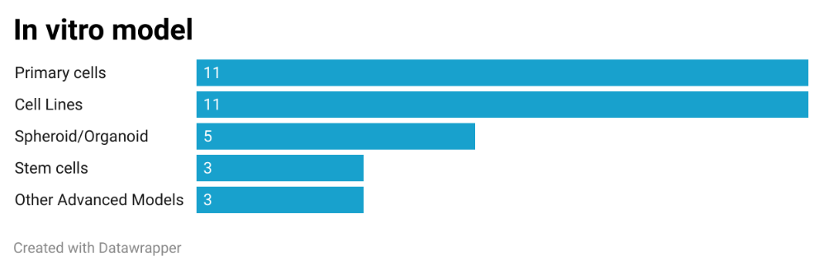
Figure 5: Frequency of use of different cellular models by the participants

3.4.2.2 Phenotyping options using in vitro cellular models in G2P research
Figure 6 provides an overview of the approaches used by participants to collect phenotypic data from their in vitro cellular models. The most widely used method is bulk transcriptomics, likely due to its accessibility and ability to provide a holistic view of cellular responses to environmental or genetic interventions. Other omics approaches are used less frequently. The second most commonly applied technique is cell imaging.
Importantly, the majority of participants utilize functional readouts from their cell models. A wide variety of assays quantifying functional cellular phenotypes were mentioned, depending on the specific cell types used, making the list of approaches quite extensive. In addition to classical assays—such as those measuring cell growth and viability—participants also reported using more targeted assays, for example to assess metabolic flux, nutrient uptake, and nutrient deposition.
This diverse collection of techniques underscores two key points: first, that functional assays are considered essential; and second, that many participants rely on customized approaches, reflecting an active and evolving area of methodological development. The breadth of these techniques also points to the need for a more systematic survey to map the existing research infrastructure across the EU and facilitate broader access to these valuable resources.
Regarding emerging technologies, participants frequently mentioned single-cell omics, including single-cell and spatial transcriptomics and proteomics. However, as shown in Figure 2, these advanced techniques are not yet widely applied. In addition, participants identified upcoming developments in robotics for automated phenotypic data collection, as well as AI and deep learning methods for predicting cellular phenotypes and the outcomes of experimental perturbations.

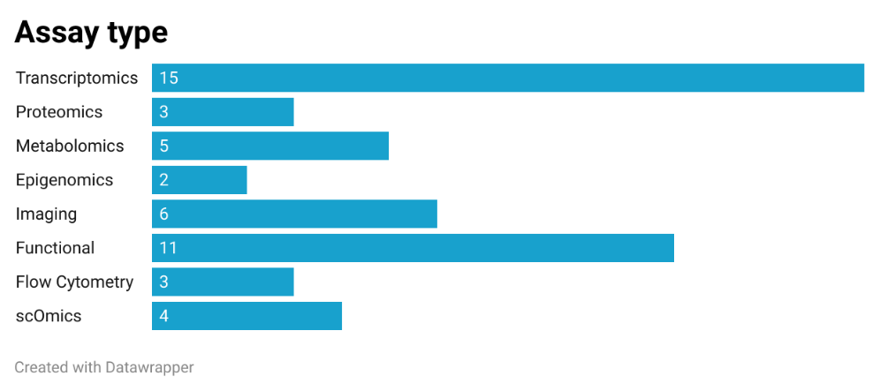
Figure 6: Frequency of application of different phenotyping approaches by the participants

3.4.2.3 Approaches and Infrastructure for Linking In Vitro Models with In Vivo Data in G2P Research
Approximately two-thirds of the participants indicated that they are, in one way or another, connecting their in vitro research with in vivo data. A synthesis of the responses shows that the most common approach is to correlate gene expression data obtained from in vitro models with phenotypic observations—including gene expression—from in vivo studies. In vitro experiments are also used to inform and optimize perturbations in in vivo experiments.
Participants most frequently mentioned single-cell and spatial omics technologies as well as advanced imaging techniques as current methods for linking in vitro and in vivo research. Additionally, there was a strong emphasis on the need for data-sharing platforms, which are viewed as essential for enabling integrative analyses across different layers of functional data—such as combining imaging data with spatial transcriptomics—and for supporting the development of computational tools (e.g. using AI) for such purposes. Data sharing is also seen as an important opportunity to validate findings. The usefulness of such platforms would be significantly enhanced if data were made available in FAIR and machine-readable formats.
A deeper understanding of cellular interactions and cell function within their native tissue context was identified as a key prerequisite for improving in vitro cellular models. In this context, the development of tissue cell atlases, as currently being undertaken in human biology, was seen as an important first step. Participants also proposed the creation of biobanks of cells, such as stem cells derived from deeply phenotyped animals, from which advanced in vitro models could be developed for use in parallel in vitro and in vivo studies. At the same time, participants highlighted the continued need to improve simpler models, such as established cell lines.
Approximately half of the participants indicated awareness of scientific networks relevant to bridging the gap between in vitro and in vivo research. While EuroFAANG was mentioned several times, most of the networks cited were from outside the farm animal research community, indicating a notable gap in this area. The other mentioned networks included:

- Aquaexcel3.0 EU project
- Utrecht Platform for Organoid Technology
- Le Groupement de recherche Organoides
- The Netherlands Organ-on-Chip Initiative
- EUROoCS - The European Organ-on-Chip Society
- INFRAFRONTIER - the European Research Infrastructure for Modelling Human Diseases
- SCOG - Single Cell Omics Germany

3.5 Conclusions and Next Steps
The activities within this task identified a wide range of potential applications for in vitro models to support key objectives related to the Green Deal and Farm to Fork strategies for optimisation of research use. However, discussions with the community highlighted a prevailing concern regarding the limited utility of in vitro systems—particularly their capacity to replace in vivo experiments and to reliably translate findings. Below, we outline the major challenges and present an inventory of proposed solutions to bridge the gap between G2P research conducted on the cellular level in vitro and organismal level in vivo. While not exhaustive, this inventory aims to highlight key approaches and outline important next steps.

A fundamental challenge lies in the biological and technical limitations of existing cell models. Addressing these limitations requires targeted efforts. Progress may begin with the optimization of models of limited complexity that retain their practical utility. Improved characterization of existing cell lines is still relevant, along with the development of new lines—especially for species with limited availability. A key requirement in this context is the establishment of reliable cell-type markers to confirm identity. Additionally, enhancing culture conditions is necessary to preserve cell phenotype. (Epi)genetic instability remains a significant concern and must be carefully monitored.

Although more advanced cellular models are emerging, their adoption across all farmed species is still in its infancy and must be systematically developed. Where applicable, protocols from well-established model species should be transferred, and undertaking common efforts toward standardization is critical to promote their broader use. These developments require coordination, and the EuroFAANG RI is uniquely positioned to provide leadership in this area. Platforms established in WP4 and WP5 can serve as hubs for building the necessary networks and research infrastructures.

Both simple and advanced models benefit from a deeper understanding of the in vivo biology they aim to replicate. This would help to deconvolute complex phenotypes measured at the whole-animal level into key processes at the organ or cellular level. The development of resources such as cell atlases is essential for gaining insights into tissue organization. While advanced models offer improved cellular contexts, a comprehensive understanding of cell–cell communication is first required to approach systemic fidelity. The rapidly expanding portfolio of single-cell omics applications presents new opportunities to resolve cellular composition and functional states at unprecedented resolution; however, their use in farm animal G2P research remains limited. To address this, FBN is organizing a two-day workshop, “The Multiverse of Workflows in Single-Cell Analysis”, focused on single-cell analysis, in June 2025. This initiative aims to support broader adoption of single-cell omics within the community, and such efforts should be further pursued and expanded by EuroFAANG RI.

Efforts to bridge the in vitro–in vivo gap are ongoing but remain fragmented and small in scale. Foundational experiments that conduct parallel in vitro and in vivo studies are needed—ideally using commercial genetic lines to enable broader extrapolation and application in breeding contexts. This will require the establishment of biobanked, deeply phenotyped populations. Such studies would help to identify where in vitro models fall short, where they already provide predictive value, and how they can be further refined. Moreover, they would generate valuable datasets for training AI-driven predictive models and serve as benchmarks for validating experimental outcomes. Importantly, they would also function as case studies to demonstrate the practical utility of cellular models.

The systematic development of assays measuring functional phenotypes beyond molecular endpoints is also critical to advancing G2P research and integrating in vitro and in vivo approaches. Many relevant assays already exist, and numerous laboratories provide a strong foundation for a coordinated research infrastructure.

All of these efforts should ultimately support the development of accessible and standardized metadata, data resources and databases. Ensuring open data sharing and interoperability will be essential to achieving long-term impact and delivering community-wide benefits.

Against this background, the EuroFFANG RI consortium, together with partners from recent INFRAIA projects — AQUAEXCEL3.0, PIGWEB, and SmartCow — has formed a consortium to merge genotype-driven (G) and phenotype-driven (P) approaches to advance G2P research and improve farmed animal husbandry in line with the European Green Deal and Farm to Fork strategies.
The "GenoPHEnix" initiative has submitted a proposal for the inclusion of new Research Infrastructure (RI) projects into an updated version of the ESFRI Roadmap, to be completed in 2026.
The proposed GenoPHEnix Research Infrastructure (RI) seeks to establish a pan-European, multi-species, multidisciplinary platform for animal genetic resources, phenotyping, and sustainable breeding, with a focus on improving animal health, welfare, resilience, and efficiency.

4. Annex

4.1 Whiteboards capturing ideas that emerged during the workshop discussions
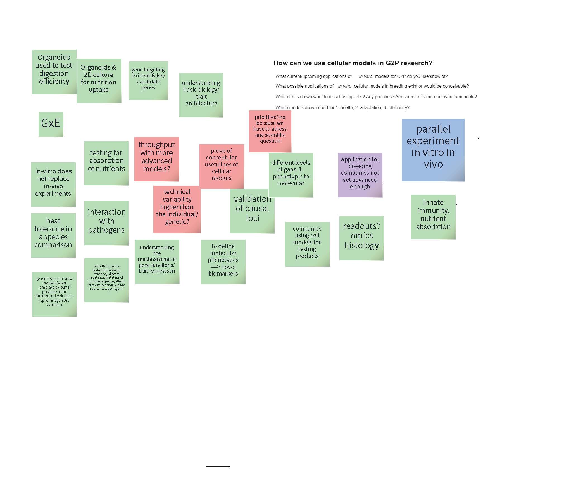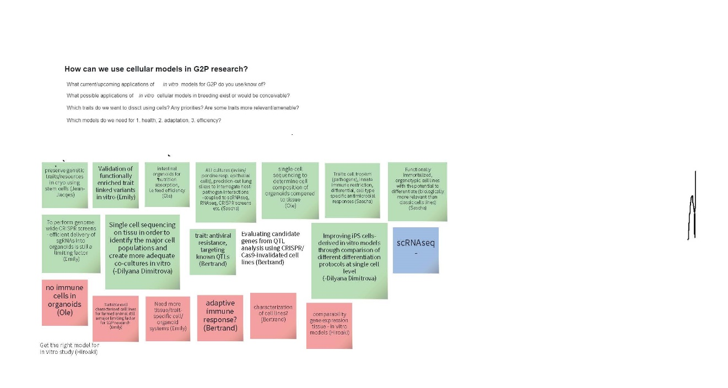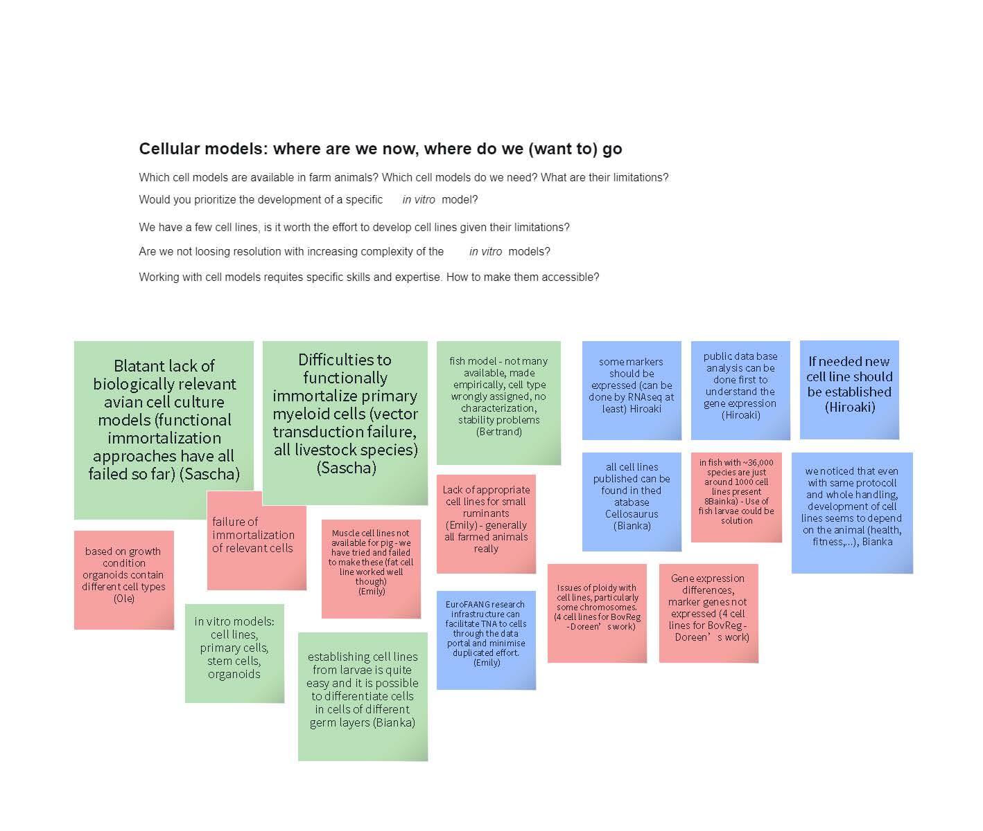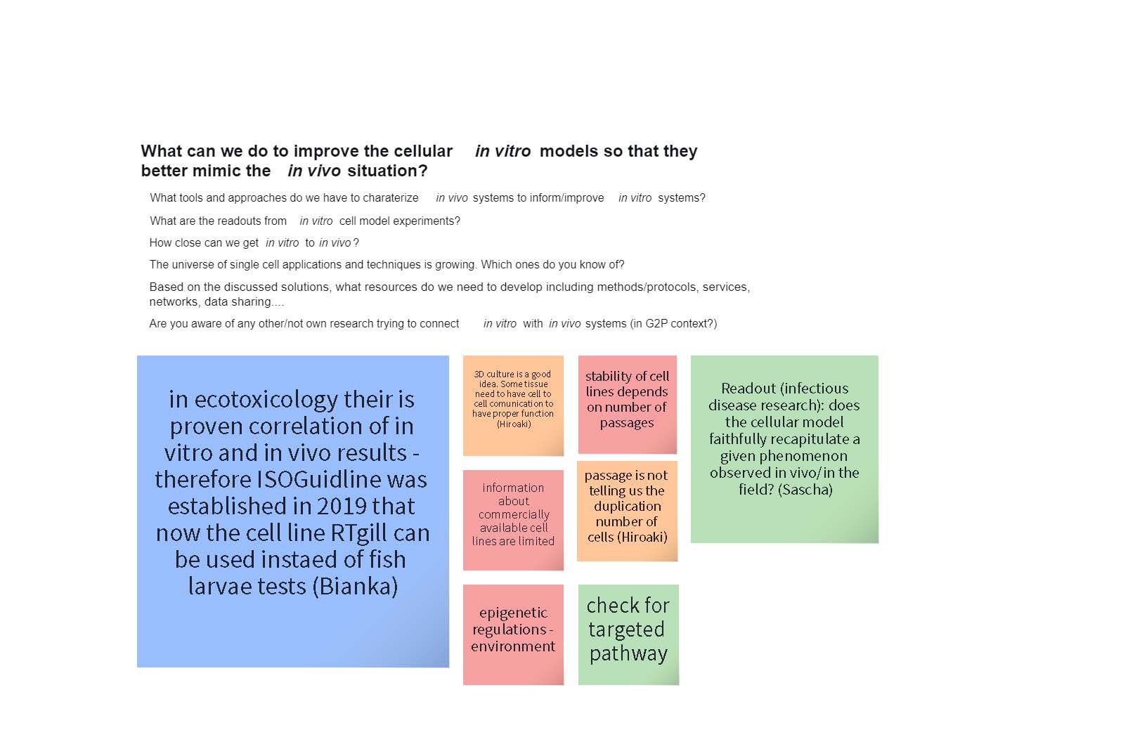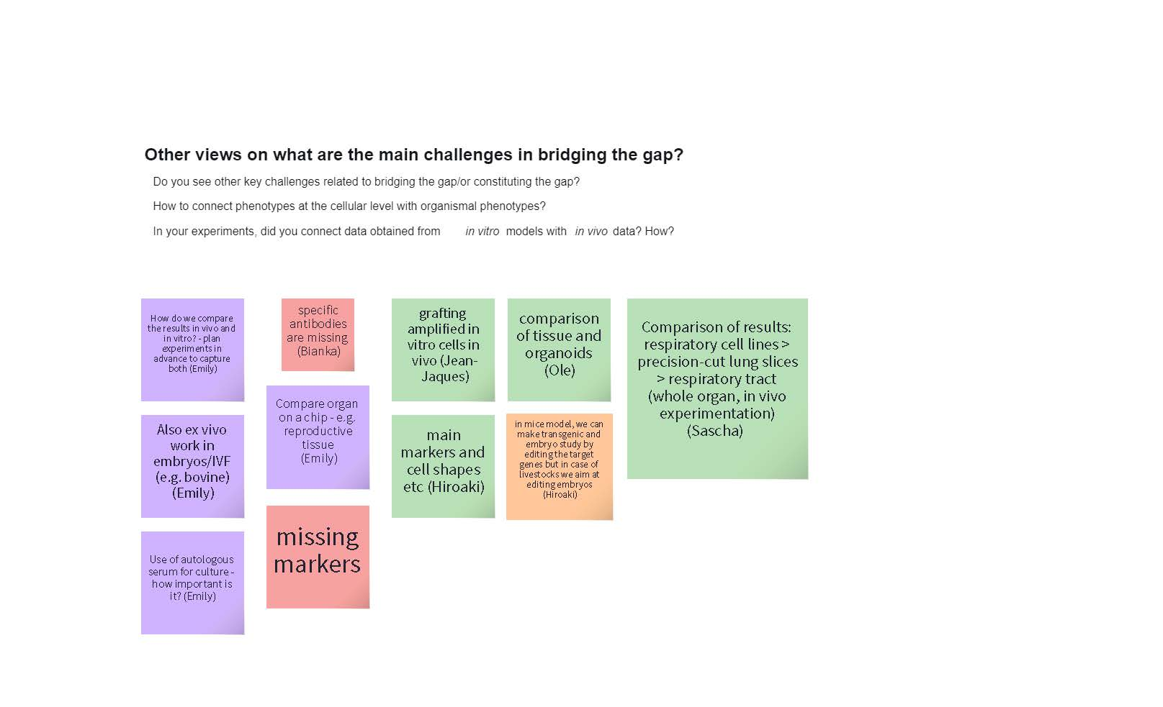

4.2 Agenda of the G2P In a Dish workshop (3rd-7th February 2025, Jouy-en-Josas, France)

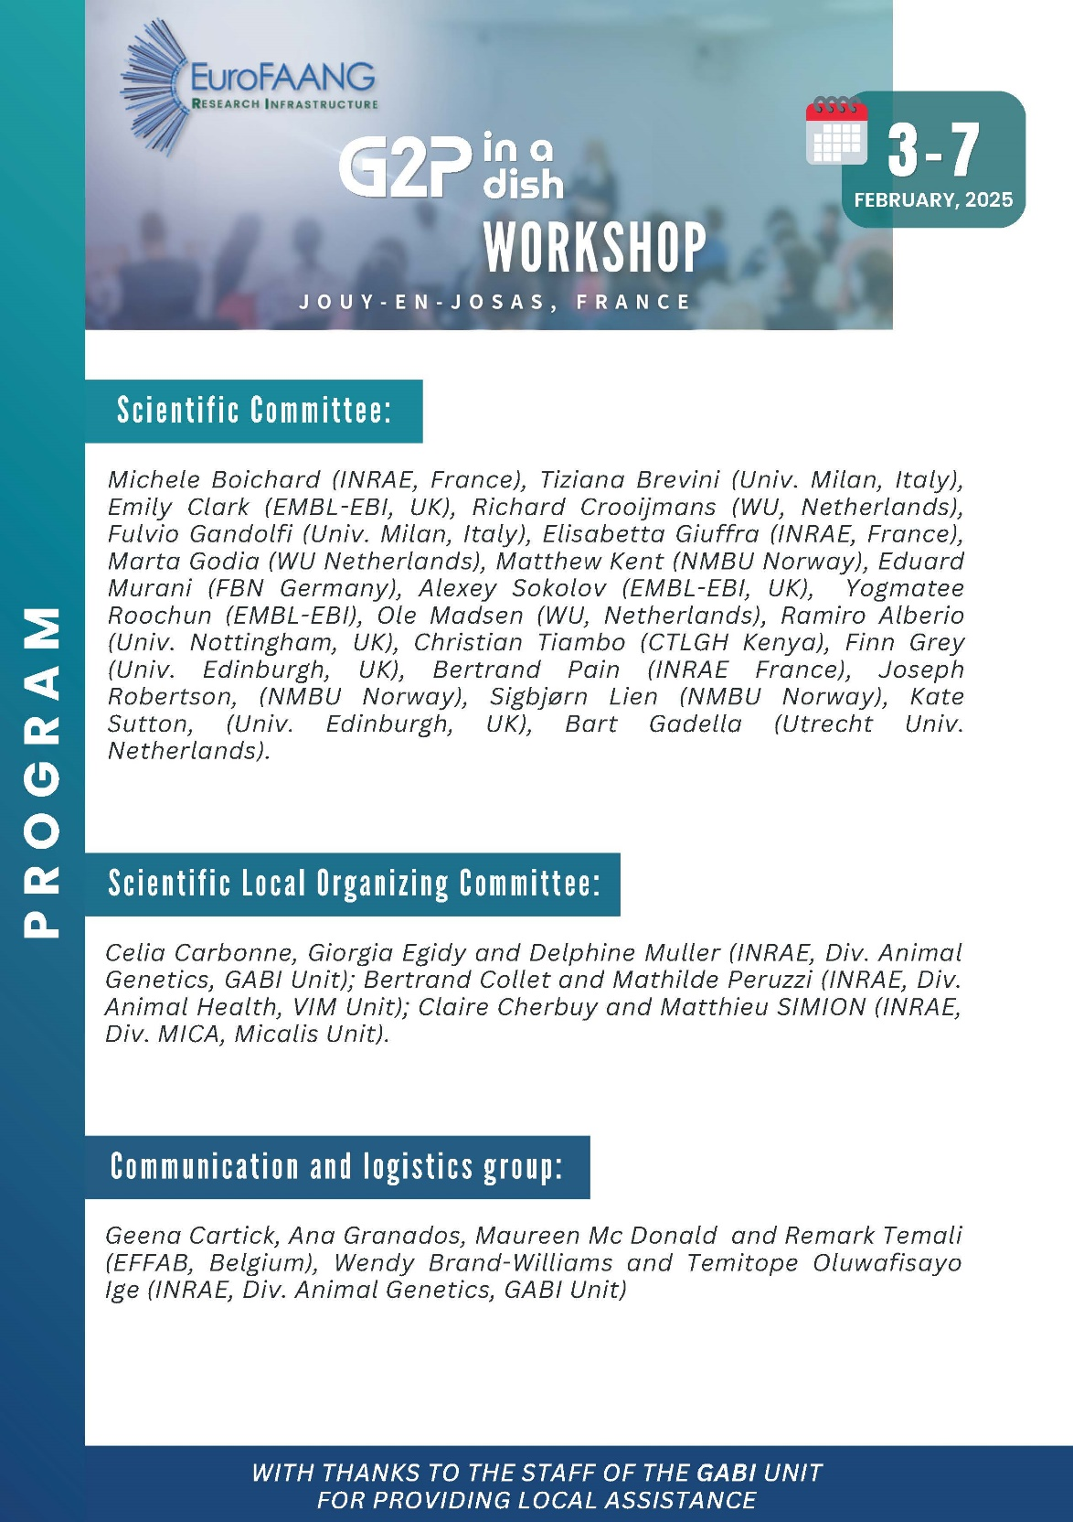

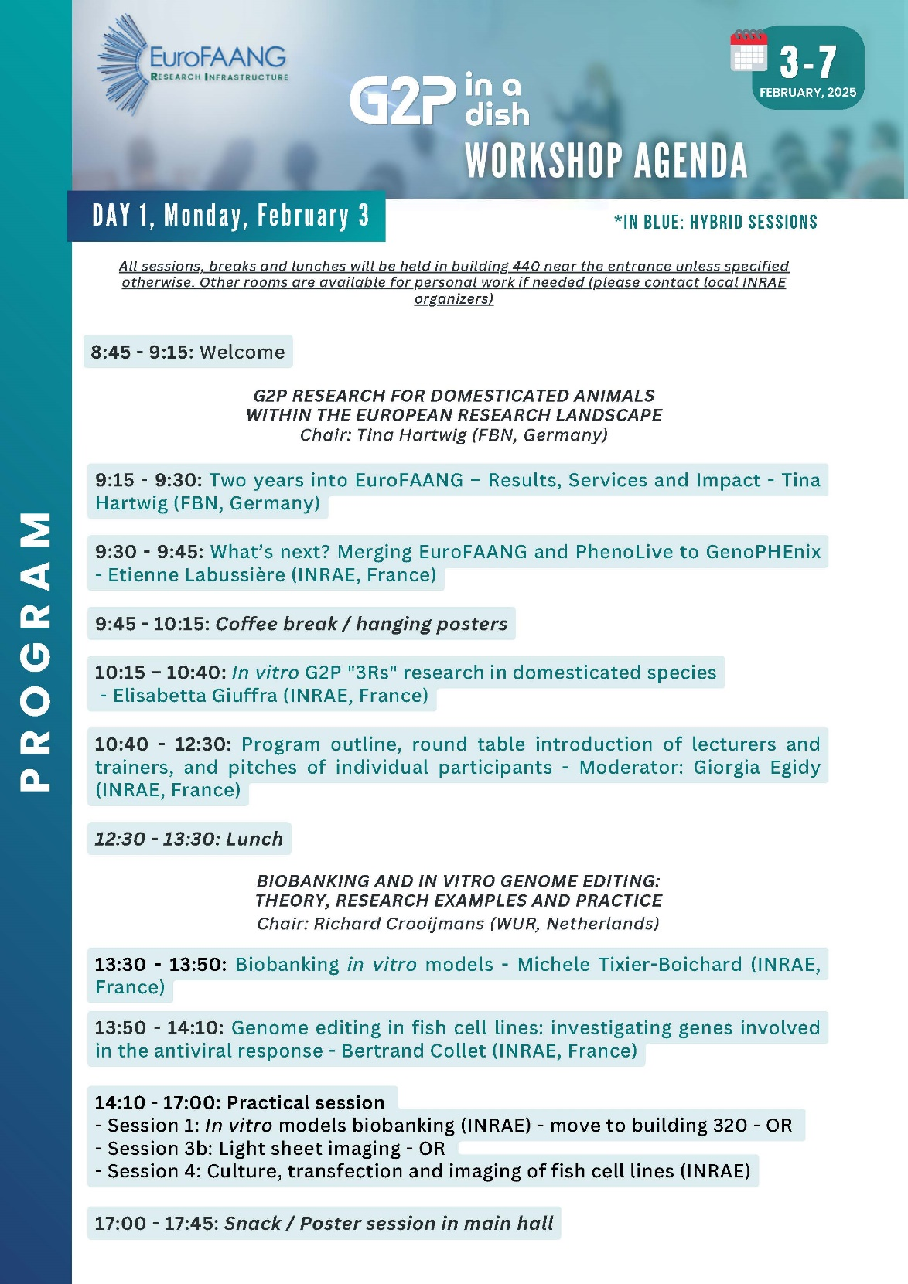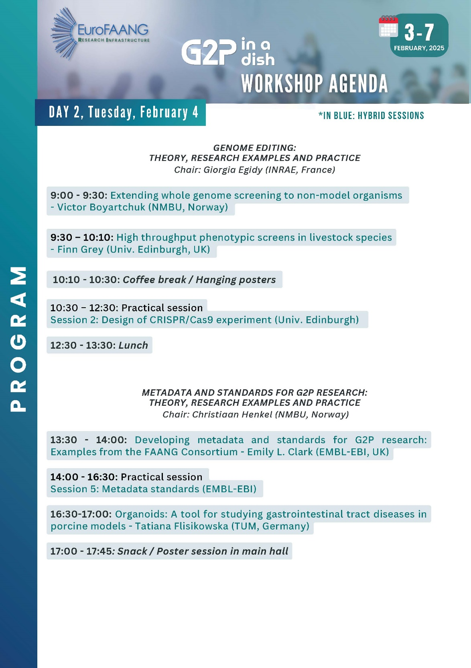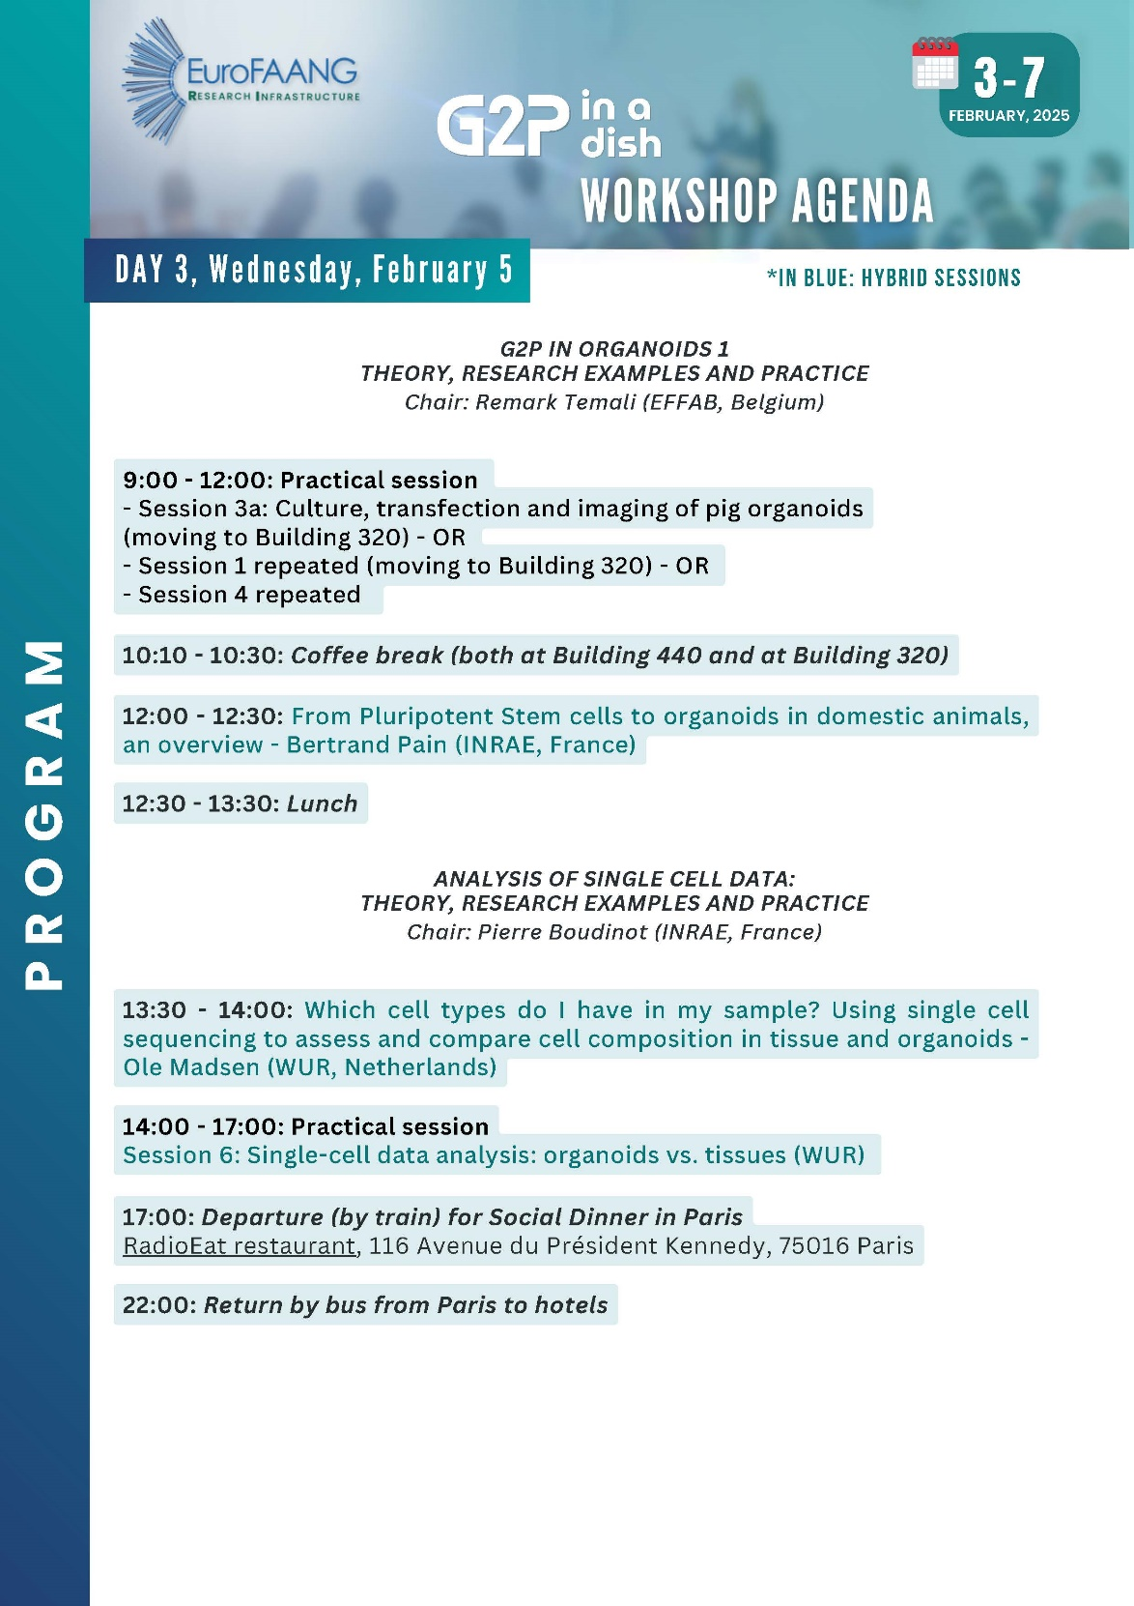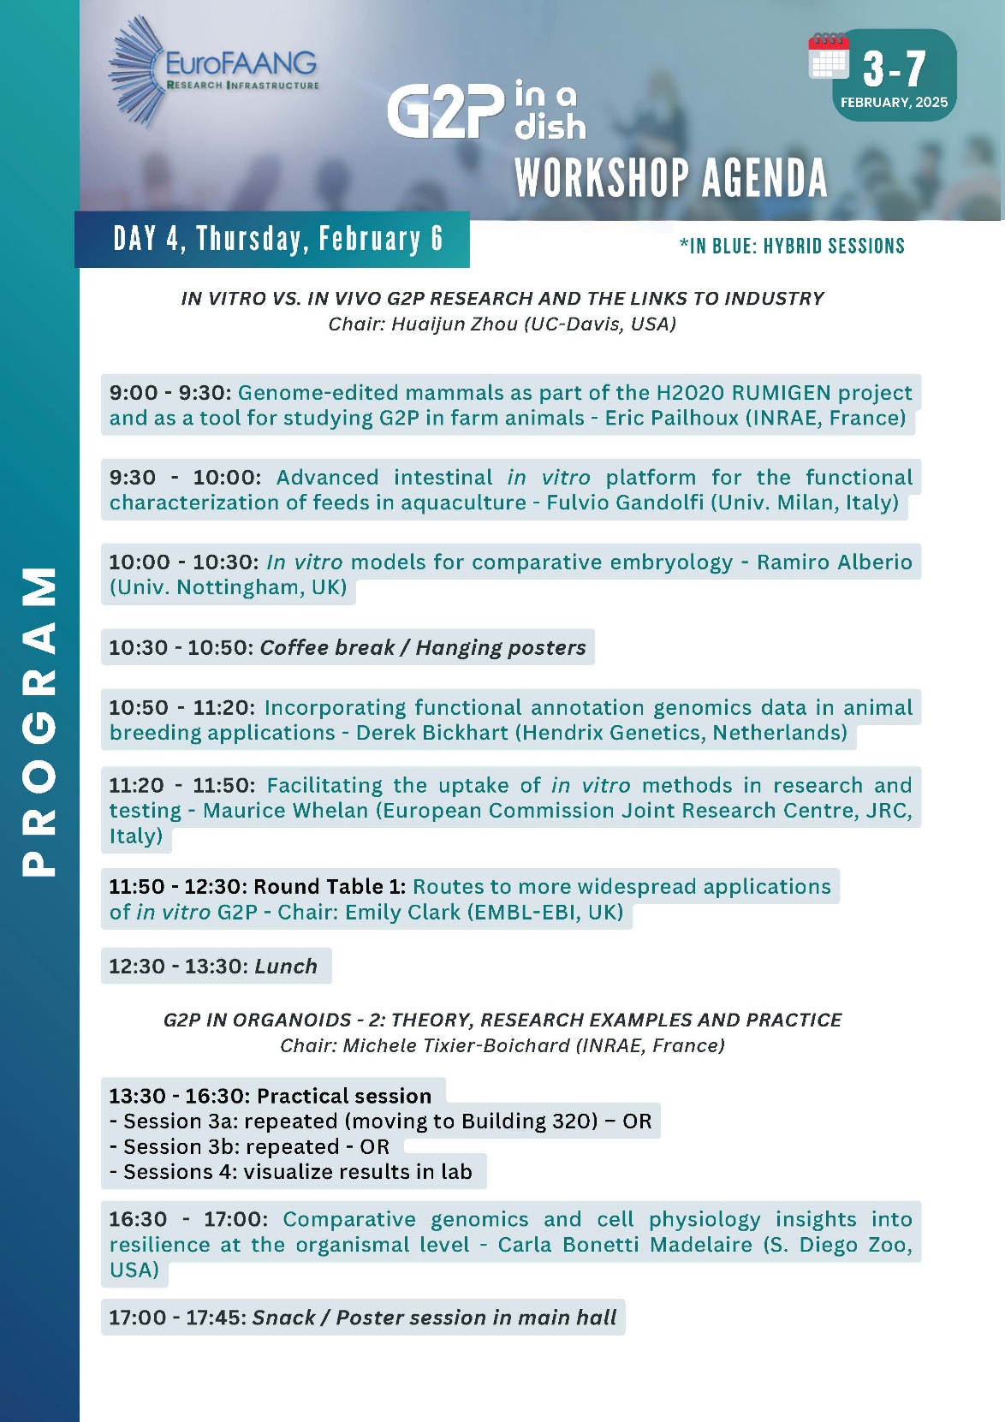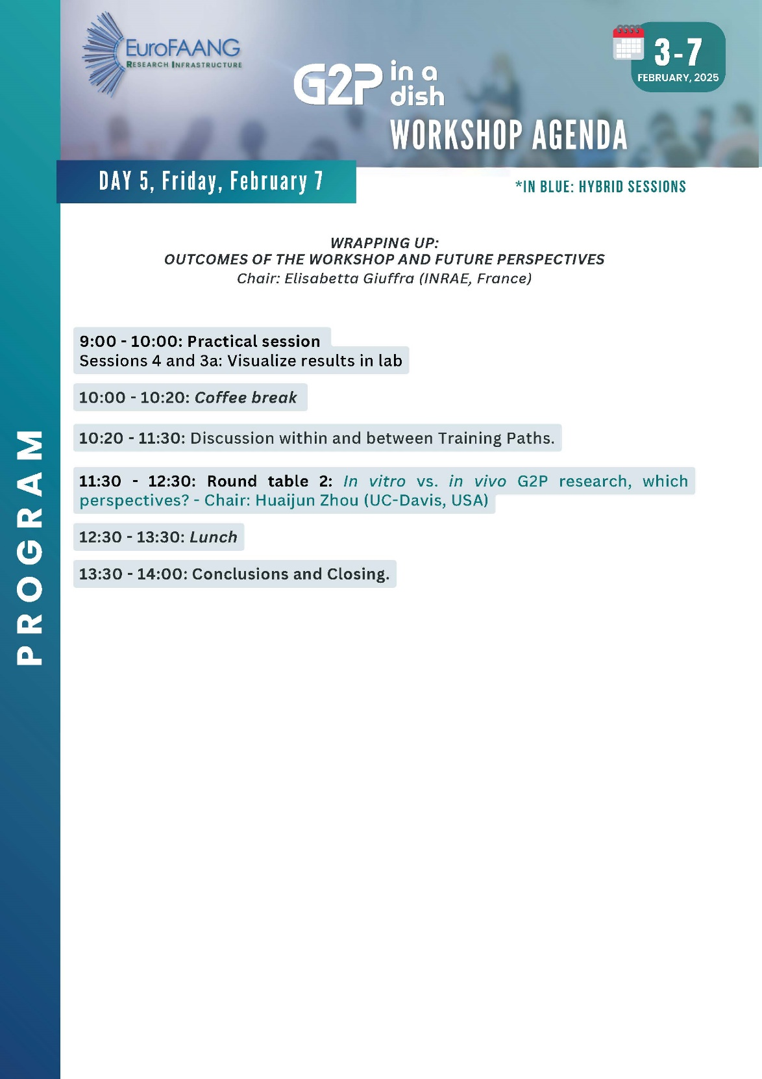

4.3 Updated survey form
