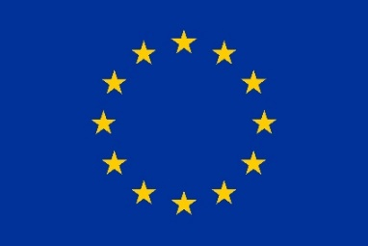
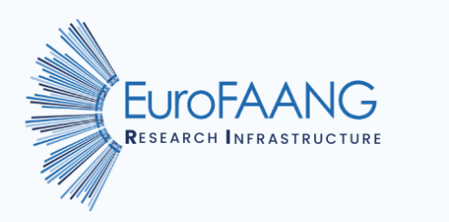

A European infrastructure
for farmed animal genotype to phenotype research

Deliverable 6.2
Report on existing and required interfaces to the animal farming industry for integrating genome and phenotype information

Grant agreement no°: 101094718
Due submission date
2024-December-31
Actual submission date
x

Responsible author(s):
Sigbjørn Lien (NMBU); sigbjorn.lien@nmbu.no
Joseph Robertson (NMBU); joseph.robertson@nmbu.no

Confidential: No

This project has received funding from the European Union’s Horizon Europe research and innovation programme under grant agreement No 101094718. The content of this report reflects only the author’s view. The European Commission is not responsible for any use that may be made of the information it contains.

DOCUMENT CONTROL SHEET
Deliverable name | Report on existing and required interfaces to the animal farming industry for integrating genome and phenotype information
Deliverable number | Deliverable 6.2
Partners providing input to this Deliverable | NMBU, UEDIN, EFFAB, FBN, INRAE, WU
Draft final version  circulated by lead party to:  On date | All WP6 partners, 11th December 2024
Approved by (on date) | x
Work package no | 6
Dissemination level | Public

REVISION HISTORY
Version number | Version date | Document name | Lead partner
Vs1 | 5.12.24 | EuroFAANG_D6.2_v1 | NMBU
Vs2 | 16.12.24 | EuroFAANG_D6.2_v2 | Edited by NMBU after feedback from WU, UEDIN, EFFAB, INRAE and FBN
Vs3
Vs4
Vs5

Changes with respect to the DoA (Description of Action)
This version of the deliverable is in line with the DoA description for D6.2. The submitted version represents a living document that can be updated after further events/discussions in 2025 (e.g. a potential workshop on public/private sector interfaces as discussed in Section 2).

Table of Contents

1. Introduction/summary of activities 3
2. Online Survey on public-private sector interfaces in farmed animal G2P research 4
2.1 Survey design and participant profiles 4
2.2 Results 6
3. Data encryption webinar and follow-up discussions 11
3.1 Webinar 11
3.2 Follow-up discussions 12
4. Other meetings and discussions related to industry/academia interfaces 14
4.1 AQUA-FAANG final conference industry day 14
4.2 Short perspectives from GENE-SWitCH and BovReg regarding collaboration and data sharing with industry 16
4.3 Meeting with representatives from Norwegian breeding companies (Geno, Topigs Norsvin, AquaGen and Genomar) 16
4.4 Discussion with the global animal health company Zoetis 17
5. Citations 18

Introduction/summary of activities
The EuroFAANG research infrastructure (RI) aims to enable genotype to phenotype (G2P) research in farmed animals by the wider European research community by providing access to:

1. Data, including genomic and phenotype data, and sample metadata.
2. In vitro cellular models to link in vitro and in vivo phenotypes.
3. Biobanks of reference samples, including organoids and genome edited cell lines.
4. World leading expertise in G2P research for farmed animals.
5. Training to establish the next generation of researchers in farmed animal science.

To maximize the impact of these resources, it is important to ensure that both academic and industrial users are primed, equipped and motivated to engage with them. This document describes a range of activities undertaken during the first two years of the project’s funding period (January 2023 to December 2024) aimed at assessing existing interfaces between private and public sectors in farmed animal G2P research, and opportunities to improve such interfaces. Additionally, we also aimed to gauge the interest from industry in accessing services/resources provided by a EuroFAANG RI.

Public and private sectors may collaborate in various ways (data/metadata/protocol sharing, joint research projects, access to laboratory services and facilities, shared students, etc.). Consequently, the nature of cross sector interfaces can differ widely (including collaborations related to all five areas of RI services listed above). However, this initial report focuses primarily on data access; 1) how, and to what extent, is G2P data already shared between sectors for different farmed animal species, and 2) how can sharing of data be improved and streamlined in ways that benefit both sectors at the interface. Enhancing data sharing is important for reaching key animal farming sustainability goals more quickly and effectively. For instance, the extensive amount of phenotyping data generated by industry holds immense value for a wide range of stakeholders. Improved data sharing is important also considering the growing requirements from funding agencies and scientific journals to make research data publicly available.

We have used three approaches to collect information included in this report:
- Our main approach has involved creating and sharing a survey titled ‘Public-private sector interfaces in farmed animal research’ (Section 2 below). This survey is still open for responses, and we will continue to actively promote it throughout the remainder of the funding period.
- In addition to the survey, we organized a webinar and follow-up discussions about the potential for data encryption strategies to streamline and expand the sharing of data within and across sectors. This approach aligns with the Agricultural Genome to Phenome Initiative (AG2PI) in the United States (Section 3).
- Finally, we also report on other discussions regarding industry uptake of EuroFAANG project data and industry interest in services and resources that could be included in the EuroFAANG RI service portfolio (section 4).

Online Survey on public-private sector interfaces in farmed animal G2P research

2.1 Survey design and participant profiles
The survey was designed by project participants from NMBU, with support from UEDIN and EFFAB, to assess the current landscape of cross-sector collaboration and data sharing practises in G2P research for farmed animals. The primary goal was to identify opportunities for enhancing data sharing and improving collaboration between public and private sectors. To maximize participation, the survey was intentionally kept short with an estimated completion time of 5-10 minutes).

Survey participants were asked to reflect on the extent to which they already use data from another sector and which platforms they use for this purpose, the need for better data/resource sharing in their sector, and their thoughts on the potential for data encryption to alleviate concerns over intellectual property/data confidentiality. For a full list of questions see Milestone 6.2 report.

We began circulating the survey, which was in a digital format, in October 2024. Since we deemed the survey as relevant to a broad audience, it was distributed widely via email, including to contacts at all six EuroFAANG RIA projects (AQUA-FAANG, GENE-SWitCH, BovReg, GEroNIMO, Rumigen, HoloRuminant). It was also sent to contacts at the Pigweb project, AnGenMap and Research Data Alliance network, public and private sector contacts from the EFFAB and FABRE TP networks, and targeted individuals who have taken part in relevant discussions at EuroFAANG or related meetings.

At time of writing (end of November 2024), the survey has received 55 submissions, the results of which are discussed in more detail below. In total, ten surveys were completed by private sector employees, 40 were completed by public sector workers (academia, public research institute etc.), and five were completed by persons identifying as working in both sectors. The higher number of responses from the public sector likely reflects the greater number of public sector contacts amongst current EuroFAANG project partners and is something we should look to correct as we seek more responses to the survey in 2025.

We received responses from researchers whose work focuses on a range of ‘classical’ farmed animal species, with no clear bias towards a particular species (Fig. 1). Sixteen of the respondents mentioned ‘other’ species that are a focus of their research, including shellfish, horses, goats, and insects. It is noteworthy that, of the 15 respondents working in the private sector (private sector only, or both private and public sector), more than half (8) work purely with finfish (and in one case, also shellfish). Responses from private sector workers for other classical farmed animal species was relatively low, and this is also something we should focus on correcting when more responses are sought.

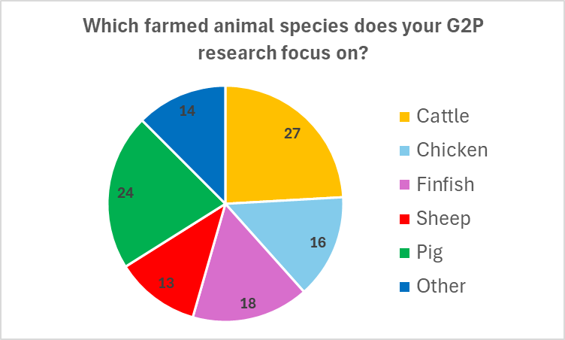
Figure 1: Pie chart showing respondents’ answers to the question “Which farmed animal species does your research focus on?”. Note the higher number of species than survey respondents (55), since it was possible to answer with more than one species.

2.2 Results

2.2.1 Current state of cross-sector collaboration and data sharing
The first set of questions aimed to assess the current state of cross-sector collaboration in farmed animal G2P research. For example, to what extent is data from other sectors used, and which platforms or interfaces do you use to access this data? As shown in Figure 2, most respondents are actively using data from another sector (i.e. an academic using data generated in industry, or vice versa), either occasionally (15 respondents; 27%) or often (29 respondents; 53%). Of note, all but one respondent from the private sector is currently using data from the public sector, which could indicate a stronger dependence on cross-sector collaboration for the private sector, but the low number of survey responses from the private sector prohibits a clear conclusion.

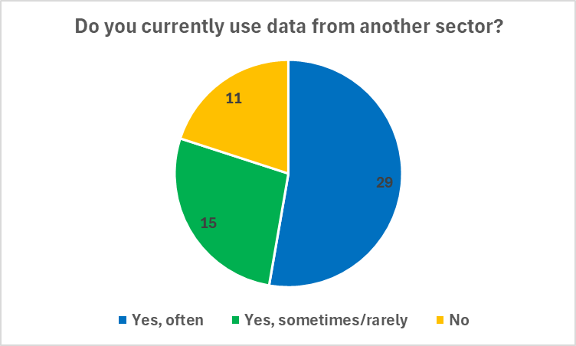
Figure 2: Pie chart showing respondents’ answers to the question “Do you currently use data from another sector (i.e. an academic using data generated in industry, or vice versa)?“
The most common platform that respondents are currently using to access/share data across sectors is via direct communication with the data creator (mentioned by 22 out of 41 respondents who answered this question). This is consistent with preconceptions among EuroFAANG partners, who have highlighted that most current data sharing between industry and academia is bilateral within joint research projects, with material transfer agreements (MTAs) describing the use of data and publication strategy. Other common platforms for data access mentioned by survey respondents include genome browsers (e.g. Ensembl), data portals (e.g. FAANG data portal), and databases (e.g. ENA, Dryad, NCBI), all of which were mentioned by multiple respondents. Other platforms mentioned include respondents‘ own developed pipelines, SLU Dairy Data Collection infrastructure, UCSC genome browser, Github, and the zebrafish information network (ZFIN).

We next asked respondents to score the extent to which they feel academia and industry are already collaborting and sharing data/resources in their field. As shown in Figure 3, very few respondents believe there is currently little to no cross-sector collaboration (i.e. a score of 1; stated by 3 respondents), while only a small number feel there is already very high levels of collaboration (i.e., a score of 5; stated by 7 respondents). Rather, the majority of respondents gave a score between 2 and 4, indicating that while collaboration between sectors is active (consistent with Figure 2), there is still potential for increased or improve collaboration.
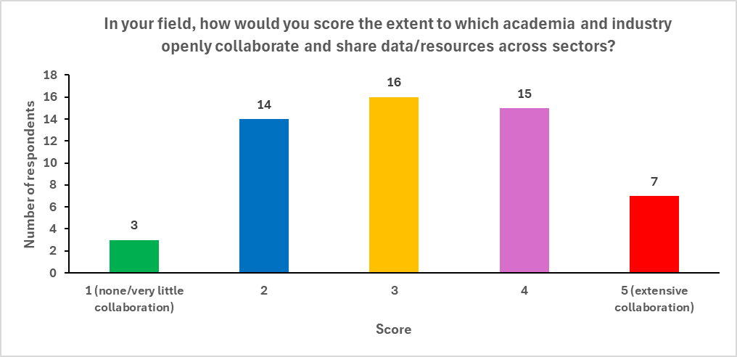
Figure 3: Bar chart showing respondents’ answers to the question “In your field, how would you score the extent to which academia and industry openly collaborate and share data/resources across sectors? (1= None/very little sharing and collaboration, 5 = Extensive collaboration and sharing)“
We explored whether there are differences in cross sector collaboration between species with relatively well established and well resourced research efforts (e.g. livestock) compared to other species such as finfish. However, this proved not to be the case, with little difference between the mean score for each species (highest mean was finfish (3.44) followed by cattle (3.26), sheep (3.23), chicken (3.0), and finally pig (2.88)). It is also noteworthy that the scores were not consistent amongst respondents working on the same species, i.e. all species received a range of scores from high (5) to low (1 or 2). This demonstrates a difference of opinion regarding current levels of cross-sector collaboration amongst people working with the same farmed animal species.

We asked respondents to reflect on the current barriers to better sharing of resources and data across sectors. By far the most common response was data confidentiality and intellectual property concerns (40 responses), which is directly relevant to our discussions on data encryption strategies (see section 2.2.2 and section 3 below). Many respondents also identified lack of cross-awareness of the research activities undertaken in each sector as a barrier to better collaboration (21 responses). In contrast. only a few people thought that physical/geographical location was an issue (4 responses), and just one respondent thought collaboration was unnecessary (i.e. no need to share).

2.2.2 Data encryption as a route to improve data sharing
We next wanted to assess the extent to which people are aware of (or already using) data encryption techniques as a potential route to sharing confidential data. To this end, we asked respondents if they thought cross-sector collaboration could be improved via techniqes that alleviate data confidentiality issues, such as data encryption, and whether this was a new concept or something they were familiar with. Most respondents agreed that cross-sector collaboration would be improved if concerns over data confidentiality/intellectual property rights (IPR) were alleviated by data encryption (Fig. 4). However, 17 respondents replied ‘not sure’ to this question, suggesting that data encryption is not yet a universally understood topic. Indeed, many respondents commented that they are not at all familiar with the data encryption concept. Some respondents commented that they are already using certain encryption strategies, such as encryption keys, while others highlighted that even if data can be encrypted, other issues may still prohibit improved data sharing. Issues mentioned were increased computational resources and processing times associated with encryption, the heavy workload associated with preparing data so that it can be shared (data description, data curation etc), or the lack of an apparent gain for industry in sharing their data.

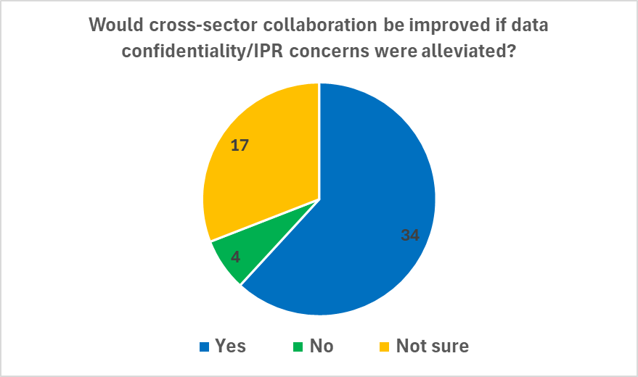
Figure 4: Pie chart showing respondents’ answers to the question “In your opinion, if intellectual property/confidentiality concerns could be alleviated by encrypting genomic and phenotyping data such that the intellectual property of the data creator was not compromised, would this help to improve collaboration across sectors?”

2.2.3 Benefits of improved data sharing
Finally, we wanted to assess what respondents feel are the major potential benefits to improved data sharing in their field. We therefore asked them the extent to which they think future improvements in animal production would be enhanced by having more data sharing between sectors, and if there are current major challenges in farmed animal G2P research that would benefit from improved data sharing. Ultimately, a EuroFAANG RI could provide a platform to help bring the relevant groups and data sharing tools together to meet such challenges. Most respondents agreed that animal production would be improved by increased data sharing between sectors (Fig. 5)
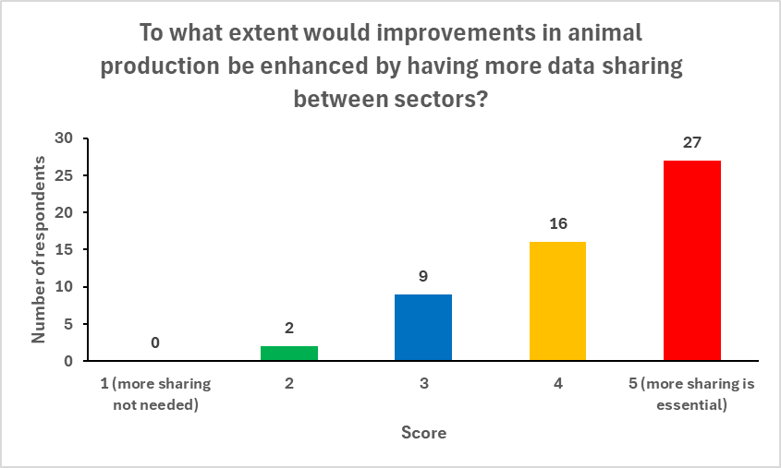
Figure 6: Bar chart showing respondents' answers to the question "To what extent do you think that future improvements in animal production would be enhanced by having more data sharing between sectors? (1= more sharing not needed, 5 = more sharing essential)“
The majority of respondents stated that major challenges exist in their field that would benefit from better data sharing (Fig. 6). The challenges listed as examples include: adaptation to climate change in farmed animal breeding; feed efficiency, improving disease resistance and animal welfare; measuring of phenotypes that are expensive, difficult, and/or time consuming to measure (e.g. methane emission); development of statistical approaches to enable use of functional genomic information in genomic prediction; breeding indices for inseminating dairy cows with semen from beef cattle; development of pan-genome resources. Some respondents highlighted that, in general, nearly all types of G2P analyses require large sample sizes, meaning that the benefits of improved data sharing would be widespread and impactful. Others highlighted that industry possesses vast datasets, such as disease challenges coupled to genetic analysis (e.g. GWAS) spanning multiple generations and experiments. In contrast, academics rarely have access to data of this scale and continuity, which enables more powerful G2P analyses. Improved data sharing could therefore facilitate the identification of causal variants for traits by integrating these industry datasets with the best academic approaches.

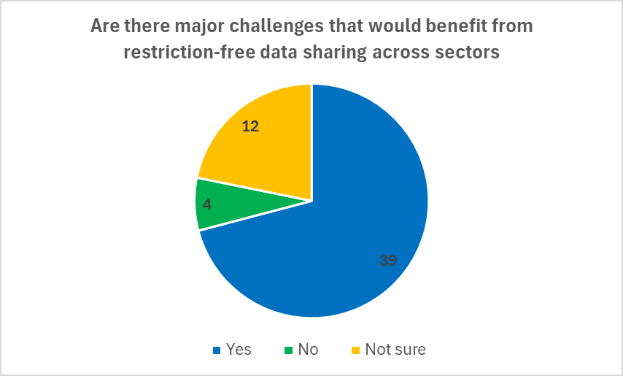
Figure 6: Pie chart to show respondents' answers to the question "Are there any major challenges/research questions in your field that would benefit from restriction-free sharing of data across sectors? For example the challenge is too big for one group/company to tackle alone.

2.2.4 Interest in future webinar/discussion
We also asked respondents if they would be interested in attending a 1-2 hour webinar/discussion about existing and required interfaces between industry and academia in farmed animal G2P research, which is something we have discussed arranging as part of Task 6.2 activities. A large number (35) replied that they would be interested in joining such a webinar (Fig. 7). As a result, we plan to organize this in the final year of the project (2025). This webinar will provide a good opportunity to further explore the topics raised in the survey and provide a platform for discussing how a European infrastructure could enhance collaboration between public and private sectors.
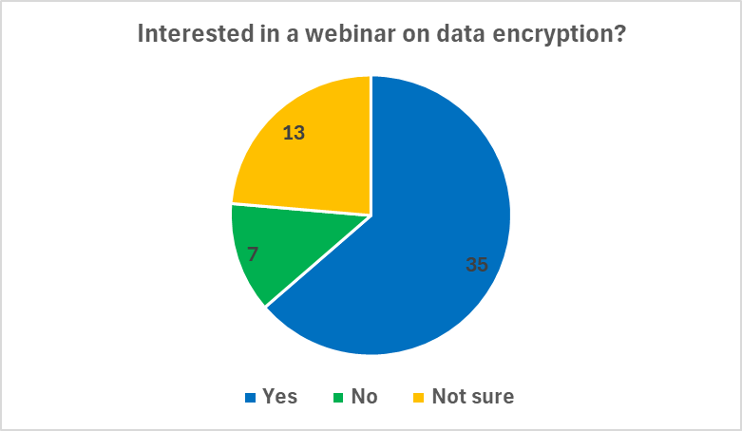
Figure 7: Pie chart showing respondents' answers to the question "Would you be interested in attending a short (1-2 hours) webinar/discussion about existing and required interfaces between industry and academia in farmed animal G2P research?"

Data encryption webinar and follow-up discussions
As mentioned in the survey questions, novel data encryption strategies have the potential to circumnavigate issues with IPR or other data confidentiality factors that are current barriers to more expansive sharing of data within and across sectors (Zhao et al. 2024).

3.1 Webinar
We organised a EuroFAANG webinar with Hao Cheng, Associate Professor at University of California (UC) Davis, who has led an AG2PI project developing a homomorphic encryption strategy for genotype and phenotype data that accommodates most widely used mixed models for genomic prediction, GWAS, and genetic parameter estimation, including Bayesian variable selection methods. The webinar took place on Tuesday 4th June and was titled ‘Platforms and methods for sharing and collaboration on AG2P using public and confidential data’. Over 30 people registered to attend the webinar, which is now available for viewing on the EuroFAANG YouTube channel. After a short introduction to the EuroFAANG RI project by Joseph Robertson (NMBU), Hao gave an overview of the AG2P-data integration, sharing, and collaboration (DISC) project. This initiative, which Hao is currently involved in, aims to develop solutions to make data sharing and joint analyses easier to perform. These topics are directly relevant to the EuroFAANG RI project, where we would like to facilitate access to genotyping and phenotyping data from different sources.

Hao discussed the importance of data sharing in the context of adherence to the FAIR (findable, accessible, interoperable, and reusable) principles in agricultural G2P studies. These principles help to ensure published results can be validated and data can be re-used in joint/meta approaches that enable more powerful analyses, e.g. in human genomics studies, the inclusion of more datasets in genome-wide association studies (GWAS) has correlated with greater numbers of GWAS loci identified per publication. Hao also outlined some of the major current barriers to more open sharing of data in different sectors, including industry data that companies consider as critical to sustaining their business. As a result, a common current solution is to establish secure databases, where joint analyses involving sensitive data are only possible through strict MTAs covering the use and sharing of the data. Subsequently, researchers are often restricted as to the journals they can publish their results in (i.e. a journal that does not require the raw data to be made publicly available, such as Genetics, Selection, Evolution), and what specific findings can be reported without violating perceived commercially valuable results. Scientific journals/publishers should, therefore, also be involved in future discussions on this topic. For example, can they accommodate confidential G2P data from companies in the same way that some journals have accommodated sensitive human data (due to privacy issues).

As an example of the benefits to data sharing amongst private sector companies, Hao provided a brief overview of the PigGen project in Canada, which focused on natural disease challenge in pigs and involved joint analysis of genotyping and phenotyping data from multiple companies. This effort would have been very expensive and challenging for one company alone but was made possible through PigGen where companies shared their data (with strict restrictions on access and sharing). This enabled more precise genomic prediction using pooled datasets compared to using individual company datasets alone.

Finally, Hao gave an overview of the homomorphic encryption strategy for genotype and phenotype data that his group has developed and gave an example of how this works based on a single trait controlled by one single nucleotide polymorphism (SNP). Hao explained how secure encryption of datasets ensures that confidential information is protected and obscured, while still allowing further validation and analyses using only the encrypted files. Importantly, such analyses using encrypted files gives the same outcomes and results (e.g. estimated breeding values) as using the raw data files, without sharing any confidential information. This approach could be of interest to the EuroFAANG research infrastructure, especially when offering resources such as genotyping and phenotyping data of sensitive nature (e.g. from industry).

The full recording of the webinar is available on the EuroFAANG YouTube channel.

3.2 Follow-up discussions
Following the webinar in June, we have continued discussions to explore the potential for incorporating data encryption strategies into the EuroFAANG RI, which aims to offer access to genotype and phenotype data, potentially from both academic and industry sources.

Briefly, some of the topics and suggested solutions are listed below:

A major issue is unwillingness of industry to share genotype and phenotype data of which they are protective. What incentives are there for industry to share their data?
- Some companies have ‘legacy data’ that has become less commercially sensitive but that can be very useful for researchers exploring new analysis tools, confirming hypotheses, developing more extensive datasets etc.
- This could be a good starting point for a EuroFAANG RI to offer access to industry data. In this case, companies would still likely prefer that any shared data was encrypted before sharing with others, as an extra layer of assurance that IPR is protected.
- ‘Smaller’ companies that do not dominate the market for a given species may be more willing to take part in joint analyses with other companies and/or academic partners, as, compared to larger companies, they are less capable of performing large expensive studies by themselves and as such have more to gain by sharing and collaborating. Two independent companies might trust an independent academic researcher to handle and analyse their data more than they trust each other. In this case, a RI can provide a platform for companies to share their data with academic researchers to perform joint analyses on their data and feed the same result back to both companies (e.g. the effect of a causal variant underlying a QTL etc.).
- ‘Bigger’ companies that dominate the market may be less inclined to perform joint analyses (possibly they have sufficient internal competence or are more concerned about loss of commercial advantages). However, these companies still seek support from academia that requires data sharing. For example, Hao Cheng regularly develops training models in the US using simulated data and has found that companies are sometimes happy to share their real data with him to see if the model produces novel positive results to their benefit. Even large companies with expansive research and development activities are unlikely to have a clear understanding of FAANG data and how to utilise it. Academics can encourage them to share their data for integration with FAANG data and to see if this is beneficial for their breeding programs.
- Irrespective of the type and size of company, data encryption is not necessarily essential (many public and private sector researchers already collaborate and share data on a trust basis), but it can lower the threshold for industry to agree to share. Furthermore, encryption can broaden the scope for publication of data (from industry and/or academia) since many journals insist on making all published data openly available. Encryption can enable reproduction of published results without making the raw data openly available.

How could data encryption strategies be incorporated into a RI that enables access to genotyping and phenotyping data?
- The FAANG data portal provides a good solution for this, where researchers could submit proposals to request specific data files (and associated metadata).
- Not all data needs to be encrypted (a large proportion would be open access data anyway) but industry is likely to want a layer of security for their own data via e.g. encryption, or legal agreements over sharing.
- The RI needs to consider data ownership and responsibility, for example if the RI comes to an end in the future, what happens to the data? In this regard, it is easier if the FAANG Data Portal that facilitates data access is only an interface that provides links to the data and metadata in the open access public databases (e.g. the ENA), or directly to industry partners with requests for access. As an interface, the portal should detail what ‘sensitive’ data is available, and could host a form to initiate requests for stakeholder access to sensitive data. If the request is accepted by the data owner, they can send the data to the user (encrypted if necessary). This is consistent with the current FAANG data portal set up, which doesn’t store data, but provides links to the open access databases including the ENA and BioSamples.
- A key issue will be whether journals/publishers accept this model of data sharing and agree that publishing the encrypted data qualifies as publishing the raw data. The research infrastructure should play an active role in discussing this with publishers.
- Access to sensitive data will need to consider firewalls, data transfer issues etc., and set up standards. For example, once data access is accepted, it would be possible to send an encryption tool to the data owner which allows simple encryption of all files for transfer. At this stage, with an appropriate MTA in place, the encrypted data could be sent to the user who has requested access. In this way, the data portal provides the connection between the data producer and end user and facilitates encryption where the owner has stipulated their data can only be used under encryption.

Other meetings and discussions related to industry/academia interfaces

4.1 AQUA-FAANG final conference industry day
The AQUA-FAANG final conference took place at the University of Edinburgh in October 2023. The three-day event concluded with an ‘industry day’ which focused on stakeholders and provided an overview of the major tools and applications that will impact the aquaculture industry in the short- and long-term future.
This day ended with a panel session exploring how results (data, models, lab techniques/protocols) from the project can be utilized by industry, and how future efforts (such as the EuroFAANG platform) could help to facilitate uptake of project results by aquaculture industry.
Some of the main take-home messages from this panel discussion are listed below:
- Currently, industry is reliant on expensive, unreliable disease challenge tests which raise animal welfare concerns and are a challenge to sustainable production. Industry is highly motivated to engage with academia who are already developing in vitro models which can be used to explore disease and other traits.
- Regarding short to medium-term (1-2 years) uptake of tools produced by the project, e.g. what are the ‘easy wins’ that the project could deliver soon for the aquaculture industry, the detection of major Quantitative Trait Loci (QTL) was highlighted as an important short-term focus. Genomic regions activated by viral infection have been identified, and industry can perform SNP-arrays focused on those regions. This should have a positive impact on prediction accuracy compared to random SNPs, particularly across more distantly related animals for viral diseases. This can be performed within months by industry, if they wish. AquaGen are already moving in this direction.
- Industry representatives highlighted that the improvement in genome annotation and the availability of the resources and databases produced by the project should not be underestimated and are useful for both academia and industry.
- Interaction between industry and academia is needed to find the best approach for prioritizing genetic variants for routine testing that have relevance to both the multitude of traits industry are concerned with, and important functional elements within a genome.
- Regarding longer term uptake of project tools and results, a number of key points were raised, including data handling efficiency (e.g. the importance of having efficient software to handle the vast amount of data generated by projects like AQUA-FAANG), sustainable aquaculture (e.g. the need to address issues related to environmental changes and sustainability in aquaculture), and the use of gene-editing to improve key traits.
- Future projects should develop decision-making tools and models to calculate expected genetic gain and the financial reward of that genetic gain, which is what industry is ultimately interested in. If you can say to industry “this is the expected return on your investment” it makes it easier to convince them to take part.
- Genome editing was highlighted as an approach with huge potential to transform aquaculture, for example creating a gene-edited Atlantic salmon that is resistant to sea lice. But there are a number of challenges to overcome before this can be realized. First, we need to identify the genes involved in resistance that could be edited, and there is still a lot to learn about how to modify the gene to get the desired phenotype. Gene editing technology and merging that technology with knowledge of gene regulation should be a focus of future projects. This is a natural follow on from projects such as AQUA-FAANG; to marry functional data with validation via gene editing, and at the same time developing the gene editing technologies so that they become more refined than current approaches. Can industry and academia collaborate towards these goals?
- Regarding a potential role for industry in future projects like AQUA-FAANG (or an ‘AQUA-FAANG 2.0’ project), it was stressed that industry partners can provide unique data sets, skills and expertise, while directly benefiting from the research output of such projects, and it can therefore be a ‘win-win’ arrangement for researchers in both sectors.
The overall consensus from representatives from commercial aquaculture was that the industry is entering into a time of opportunity where sharing and collaboration with academics is essential to future progress.

The panel discussion was streamed live, and the recording has been posted on the AQUA-FAANG YouTube channel.

4.2 Short perspectives from GENE-SWitCH and BovReg regarding collaboration and data sharing with industry

GENE-SWitCH
The H2020 GENE-SWitCH project involved a partnership with a breeding industry partner (Hendrix Genetics), collaboration with other breeding companies/association parties (Aviagen, Hypor B.V. and IFIP) and a biotech company (Hologic Diagenode). All samples, data and metadata collected and the pipelines developed are available on a dedicated page of the FAANG data portal (https://data.faang.org/projects/GENE-SWitCH). Although no commercial phenotype data were shared outside the consortium, two major industry-led developments were: i) the development of innovative models to improve genomic prediction (accuracy) in the pig and poultry sectors based on the use of functional annotations for health, reproduction and efficiency traits (published), and ii) the empirical validation of the improved genomic prediction models in large commercial pig and chicken populations. In this context, a pipeline has been developed to calculate Functional-And-Evolutionary Trait Heritability (FAETH) scores for genomic variants, i.e. to prioritise SNPs based on different levels of functional genomic knowledge for genomic prediction (liteFAETH score calculation pipeline).
These industry-led developments have been accompanied by several training, dissemination and outreach activities aimed at both academia and industry, which have been carried out as often as possible in the context of the early EuroFAANG collaboration. The outcomes of the final GENE-SWitCH conference, held in November 2023, provides a synthesis of the results and impact of the project, with access to videos of all the discussions held with several stakeholders (https://www.gene-switch.eu/final-conference1.html).

BovReg
The H2020 BovReg project involved collaboration with industry partners particularly for Genome Wide Association Studies (GWAS) and meta-analysis of GWAS studies for several different cohorts of cattle and many different traits. Access to sensitive data was managed through a private portal accessible only to specific BovReg partners, and publication was via journals such as Genetics Selection Evolution that do not require that genotypes and phenotypes for GWAS are made publicly available.

4.3 Meeting with representatives from Norwegian breeding companies (Geno, Topigs Norsvin, AquaGen and Genomar)
As Task 6.2 leader, NMBU arranged a meeting with scientific representatives from four breeding companies working with different farmed animal species to discuss the topics of data sharing and encryption. The companies represented were Geno (cattle), Aquagen (salmonids), Genomar (tilapia), and Topigs Norsvin (pigs). The feedback gained is summarised briefly below:
- Most people were unfamiliar with the data encryption concept, but they expressed interested in its potential
- Leadership in industry are likely to question what they will gain from sharing data, particularly for phenotyping data which most companies are protective of. What is the big ‘selling point’ to encourage companies to share?
- Other types of data/resources might meet less opposition: in vitro, genomic, imaging etc.
- There is clear potential in sharing data when all industry would benefit equally, e.g. lice resistance in aquaculture
- Concerns about unwittingly disclosing information that can be maliciously used to depreciate the genetic products of a breeding company.
- Some data types (e.g. methane registration) are expensive and even big companies struggle to generate enough of this data. If several big companies each generate and share this data, it benefits all of them collectively. It is important to communicate that companies would not purely give away valuable data to others who are not contributing their own data.
- Sharing data can make it easier to recruit students (more data, more opportunities for inquiry). Also, more data makes technology development easier (e.g. developing new SNP-arrays, or CRISPR screening panels etc.)
- Can sharing data help with the development of AI resources?

4.4 Discussion with the global animal health company Zoetis
Emily Clark (UEDIN) met with Zoetis to discuss the interface between academia and industry in the animal health space.
Points raised in the meeting included:
- It is important to minimise duplicated effort by maximising communication between the sectors, for example, in generation of new genomic resources, such as telomere to telomere (T2T) genomes.
- Often industrial partners have the resources to generate genomic resources (e.g. new genomes, functional assays etc) to answer their own research questions, but they are also keen to minimise duplicated effort, maximise the value of resources, and work with the academic sector.
- The quality/contiguity/annotation of the reference genomes for companion animals can be a limiting factor to progress. Improving these resources, for example, but providing links to data for companion animals via the FAANG Data Portal, visualisation tools and annotation in the Ensembl genome browser, is key to their interests in participating in the EuroFAANG RI.
- They could be interested in making TNA requests to RI for specific R&D projects.
- Access to new in vitro cellular systems and suitable platforms for screening of new therapeutics etc would be one way they would benefit from the TNA offered by the RI.
- Suitable in vitro cellular models are as much a limiting factor in companion animals as they are in farmed animal species and a key means to meet the 3R’s principles in animal research (reduction, refinement and replacement).
- The potential to better link biobanks for biological samples including from companion animals and provide associated metadata was also considered to be very important, again to try to minimise duplicated effort and provide alternatives to the use of animals in research.

Citations
Tianjing Zhao, Fangyi Wang, Richard Mott, Jack Dekkers, and Hao Cheng. 2024. “Using Encrypted Genotypes and Phenotypes for Collaborative Genomic Analyses to Maintain Data Confidentiality.” Genetics 226 (3)

