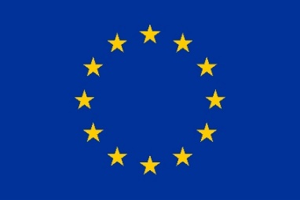
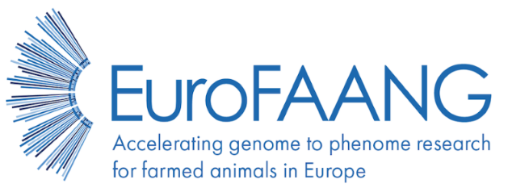

Deliverable 5.4
Resource in the form of a web portal to connect ethics committees, projects and infrastructures as a foundation for a European ‘think tank’ on genome editing
Grant agreement no°: 101094718
Due submission date
2024-06-30
Actual submission date
2024-06-28
Responsible author(s)
Geena Cartick(EFFAB)
Emily Clark (UEDIN)

Confidential No

This project has received funding from the European Union’s Horizon Europe research and innovation programme under grant agreement No 101094718. The content of this report reflects only the author’s view. The European Commission is not responsible for any use that may be made of the information it contains.
DOCUMENT CONTROL SHEET
Deliverable name | Resource in the form of a web portal to connect ethics committees, projects and infrastructures as a foundation for a European ‘think tank’ on genome editing
Deliverable number | 5.4
Partners providing input to this Deliverable | EFFAB  UEDIN
Draft final version  circulated by lead party to:  On date | All partners in task (2024-06-28)
Approved by (on date) | FBN as Coordinator (2024-06-28)
Work package no | 5
Dissemination level | Public (PU)

REVISION HISTORY
Version number | Version date | Document name | Lead partner
Vs1 | 2024-06-28 | D5.4WebPortalforGE.docx | EFFAB
Vs2 | 2024-06-28 | D5.4WebPortalforGE_v2.docx | EFFAB

Changes with respect to the DoA (Description of Action)
None
Dissemination and uptake

Table of Content

1. Summary of results 2
2. Introduction 4
3. Core report 5
3.1. Objectives 5
3.2. Methods 6
3.3. Impact 9
4. Conclusions 9

Summary of results
The EuroFAANG Research Infrastructure (RI) project, funded by the EU Horizon Europe research program, aims to develop a European 'think tank' on genome editing in farm animals that connects national ethics committees, projects, and infrastructures engaged in genotype-to-phenotype research in farmed animals. The aim of Deliverable 5.4 was to provide a web portal for the ‘think tank’ to communicate and share ideas.
The establishment of the web portal is crucial for the sustainability of the the ‘think-tank’ on genome editing for the EuroFAANG RI project due to its role in facilitating discussion amoung think-tank members to ensureethical oversight, promote collaboration and knowledge exchange, influence policy development, and standardize procedures.
The methodology for creating the web portal involved initial workshops and surveys, development of a web page with a members-only corner, and the creation of a structure that includes a resource section and a blog-style page. The portal will be enhanced over the next 18 months of the EuroFAANG RI project to include discussions on specific topics such as ethics, welfare, and societal aspects of genome editing and provide a place for discussions on research articles and new developments in the field.
The web portal it is important because it serves as a crucial link between think-tank members who represent other ethics committees, projects, and infrastructures, thereby establishing the foundation for a European 'think tank' on genome editing. It enhances collaboration, promotes responsible advancements in the field, and becomes a knowledge hub that informs policy-making and decision-making processes.
In conclusion, the creation of the European think-tank (M5.2) and the launch of the web portal are significant steps towards fostering a collaborative environment for genome editing across Europe. As the portal evolves and interaction increases, the deliverables will be updated accordingly, ensuring the portal remains relevant and effective as membership grows. The portal will play a crucial role in advancing genome editing technologies, ensuring their ethical and fair use, and focusing on improving animal health and welfare. The dynamic nature of the portal, with its ability to grow and adapt, emphasises the potential of this initiative to make a lasting impact in the field of genome editing for G2P research in farmed animals.

Introduction
The EuroFAANG RI aims to streamline interdisciplinary capabilities for Genotype-to-Phenotype (G2P) research in terrestrial and aquatic farmed animals and provide transnational access to all of the relevant facilities, expertise and knowledge to European stakeholders. This will address the need to bring together national facilities at the pan-European level in animal genetic resources, phenotyping and breeding, and animal health, which was identified as a gap in the infrastructure landscape by the 2021 ESFRI Roadmap. The proposal builds on the foundation of the six H2020 EuroFAANG projects, AQUA-FAANG, BovReg, GENE-SWitCH, GEroNIMO, HoloRuminant and RUMIGEN. It connects with existing infrastructures for data management and animal agriculture in the European research infrastructure landscape.
Within this framework, work package (WP) 5 aims to develop a framework for sharing and expanding capabilities in genome editing as a route to applying FAANG data for understanding the genotype-to-phenotype link in farmed animals. To achieve this, three main objectives or tasks are:
- Provide a route to apply FAANG data in vitro by creating a framework for access to high-throughput phenotyping (HTP) platforms to validate candidate causal variants.
- Devise a framework to facilitate access to genome editing technology in vivo in i) animal facilities equipped to handle/raise and conserve genome-edited animal lines across generations and ii) in silico modelling studies to predict the effect of introducing an edit into a breeding population.
- Creating a European think-tank on genome editing in farm animals, connecting national ethics committees, projects and research infrastructures.
The deliverable D5.4, “Resource in the form of a web portal to connect ethics committees, projects and infrastructures as a foundation for a European ‘think tank’ on genome editing”, is a critical component of WP5’s objectives, particularly for Task III. It provides a tangible, accessible platform that embodies the principles of sharing and expanding capabilities in genome editing and fostering discussion. This resource directly supports the application of data generated by the EuroFAANG H2020 projects for understanding the genotype-to-phenotype link in farmed animals, thereby fulfilling the overarching goals of WP5. The connection of ethics committees, projects, and infrastructures is a strategic move that positions the EuroFAANG RI as a leading entity in ensuring that transnational access (TNA) to genome editing for G2P research in farmed animals is fair and equitable. It provide a means for discussion about ethical use of technologies, promotes collaboration, influences policy-makingand standardises research practices, and the outcomes will shape how the concept for the EuroFAANG RI project develops

Core report

Objectives
Deliverable 5.4, is a crucial component of Task 5.3, which aims to establish a European ‘think tank’ on genome editing in farm animals. In D5.4 EFFAB has developed a web portal for the think-tank, connecting national ethics committees, projects, and research infrastructures engaged in genotype-to-phenotype (G2P) research, to advance the use of genome editing as a primary route to application of the data generated by the H2020 EuroFAANG projects.
The establishment of this web portal for D5.4 to facilitate connection of members of the think-tank is vital for the sustainability of the EuroFAANG Research Infrastructure (RI) for the following reasons:
- Ethical Oversight: Ensuring responsible and ethical use of genome editing technologies, given their significant impact on animal welfare, biodiversity, and the environment.
- Promotion of Collaboration and Knowledge Exchange: Facilitating a collaborative environment that encourages the sharing of resources, expertise, and knowledge, thereby accelerating advancements in genome editing.
- Influence on Policy Development: Providing policymakers with scientific insights necessary for developing regulations that strike a balance between innovation and ethical considerations.
- Engagement with the Public: Playing a key role in informing the public about the benefits and risks of genome editing technologies, thereby fostering an informed public discourse.
- Standardization of Procedures: Helping standardize procedures, methodologies, and ethical guidelines across different projects and infrastructures, ensuring consistency and quality in research outputs.
Deliverable 5.4 aims to create a unified platform that connects various sectors, promoting collaboration, ethical oversight, and public engagement in genome editing.

Methods
The methodology for Deliverable 5.4, aimed at creating a resource in the form of a web portal to connect members of the think-tank involved in ethics committees, projects, and infrastructures in the European farmed animal science space as follows:
- Initial Workshops and Surveys: Three virtual meetings of the think tank and one workshop at the EFFAB AGM 2023 were conducted in 2023-2024. These events and various webinars and surveys guided us in determining the optimal approach for the web portal.
- Development of a Web Portal: We developed a web page on the EuroFAANG RI website featuring a members-only corner (Figure 1). This corner allows every think tank member to register with a username of their choice, maintaining anonymity and promoting the free exchange of ideas.
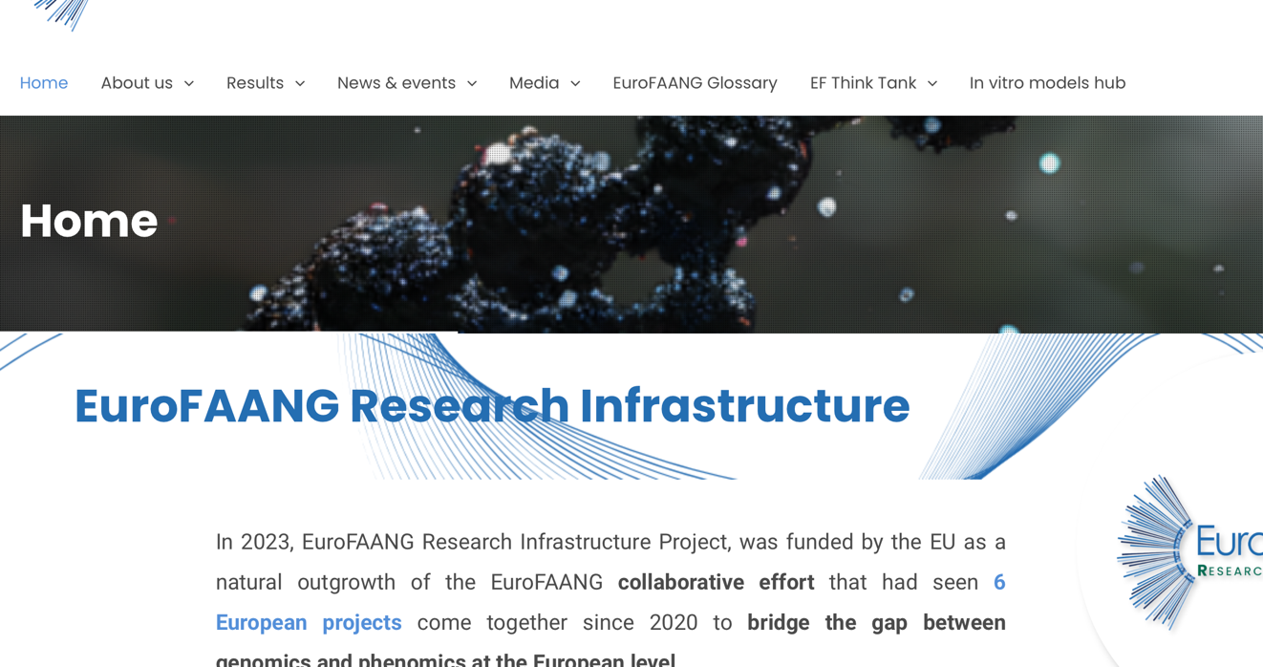Figure 1: The EF ThinkTank Hub, was added to the main EuroFAANG web page titles

- Creation of a Members-Only Corner: The members-only corner is the first step towards creating a hub that can eventually be opened to a broader network. Members need to register and have a username to access this section (Figure 2).
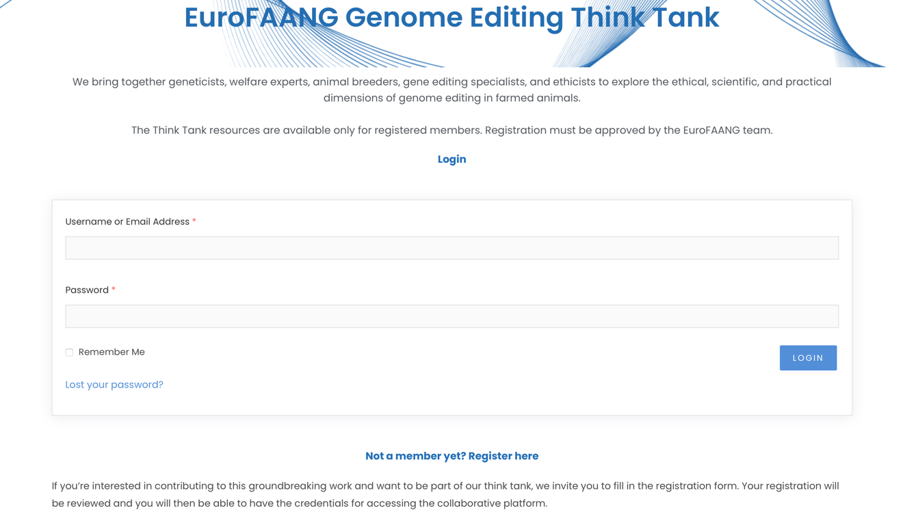Figure 2 Registration to the Web Portal
- Web Portal Structure: The web portal comprises two sections: a resource section and a blog-style page. Members can share news or articles and interact by commenting on the blog-style page (Figure 3).
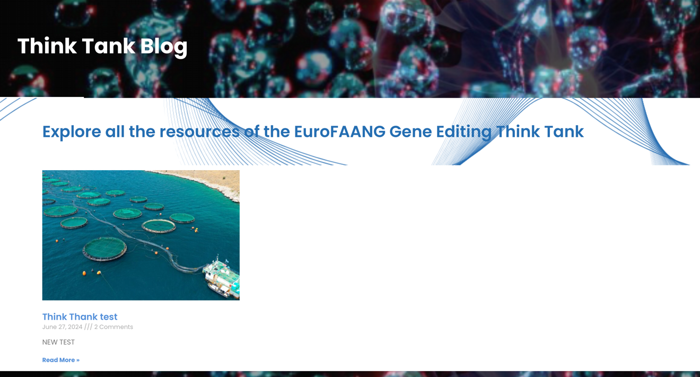
Figure 3 Sneak Peak of how the Web portal blog page will look like for sharing news articles and ideas

- Inclusion of Specific Topics: Over time, the page will be enhanced to include discussions on specific topics such as ethics, welfare, and societal aspects of genome editing.
- Member Engagement: The next step is encouraging members to join the web portal and increase interaction. We will continue to upload “Gene Editing News” from EFFAB and FABRE-TP and disseminate current news and information on this theme. This will allow members to comment, interact, and exchange ideas, contributing to the sustainability of the ‘think-tank’ on genome editing and the EuroFAANG RI more broadly.

Impact
The web portal, has a profound impact as it serves as a crucial link between members of a wide diversity of ethics committees, projects, and infrastructures, thereby establishing the foundation for a European ‘think tank’ on genome editing. The impact of the portal is multi-faceted. It enhances collaboration by providing a platform for different stakeholders to exchange ideas and create synergies. It also ensures that ethical aspects of genome editing are not overlooked by involving ethics committees, thereby promoting responsible advancements in the field. As the next step to the ‘think tank’, it becomes a knowledge hub, fostering innovation through discussions and knowledge sharing. Furthermore, the collective intelligence gathered through this portal informs policy-making and decision-making processes, ensuring they are comprehensive and up-to-date. Deliverable 5.4 will provide an important community enhancing tool to advance the use of genome editing for G2P research in farmed animals and extend its impact beyond the scientific community to policy-making and societal perspectives on genome editing.

Conclusions
The creation of the European think-tank and the launch of the web portal are significant steps towards fostering a collaborative environment for genome editing across Europe. The portal already connects experts in the field and facilitates the exchange of knowledge and resources. As the web portal evolves and the interaction on the web portal increases, this deliverable will be updated accordingly. This adaptability will ensure that the portal remains relevant and effective as the membership grows. It will play a crucial role in advancing genome editing technologies, ensuring their ethical and fair use, and focusing on improving animal health and welfare. The progress underscores the power of collaborative effort and discussion across multiple stakeholder groups in driving scientific advancements and shaping policies in genome editing in farmed animals. The dynamic nature of the portal, with its ability to grow and adapt, further emphasises the potential of this initiative to make a lasting impact in the field of genome editing to advance G2P research in farmed animals.

