


Deliverable D5.1

A framework for access to high-throughput phenotyping (HTP) platforms for the validation of candidate causal variants

Grant agreement no°: 101094718

Due submission date
2024-06-30
Actual submission date
2024-06-28
Responsible author(s)

Emily Clark (UEDIN); emily.clark@roslin.ed.ac.uk
Geena Cartick (EFFAB); geena.cartick@effab.info

Confidential: No

This project has received funding from the European Union’s Horizon Europe research and innovation programme under grant agreement No 101094718. The content of this report reflects only the author’s view. The European Commission is not responsible for any use that may be made of the information it contains.

DOCUMENT CONTROL SHEET
Deliverable name | A framework for access to high-throughput phenotyping (HTP) platforms for the validation of candidate causal variants
Deliverable number | D5.1
Partners providing input to this Deliverable | UEDIN, EFFAB
Draft final version  circulated by lead party to:  On date | All partners in WP or task on 2024-06-26
Approved by (on date) | FBN as Coordinator (2024-06-28)
Work package no | 5
Dissemination level | Public (PU)

REVISION HISTORY
Version number | Version date | Document name | Lead partner
Vs1 | 2024-06-25 | D5.1 – A framework for access to HTP platforms | UEDIN

Changes with respect to the DoA (Description of Action)

The first version of this deliverable meets the requirements of the DoA. As the EuroFAANG RI project progresses and the capacity in Europe to use high throughput phenotyping platforms and CRISPR screens in farmed animals increases the deliverable will be updated annually.

Table of Content

1. Summary of Results 3
2. Introduction 4
3. Results 6
Introduction to the concept of high-throughput cellular phenotyping platforms, CRISPR screens, and other highly scalable functional assays 6
Summary of the discussion on ‘High-throughput cellular phenotyping platforms and CRISPR screens’ at the second meeting of the European Think Tank on Genome Editing 7
Opportunities 9
Priorities 9
Barriers 9
EuroFAANG RI WP5 Webinar on “The Power of G2P Research in Farmed Animals through High-Throughput CRISPR Screens” 10
WP4 workshop session to build expertise in single guide RNA design 10
Facilities with ‘High-throughput cell phenotyping platforms’ within Europe 10
France 11
Denmark 11
United Kingdom 12
Germany 13
Extending HTP capacity from human research to G2P research in farmed animals 13
Additional service provision relevant to high-throughput cellular phenotyping 14
Commercial automated cell phenotyping systems 14
Assembly of DNA constructs at scale for CRISPR screens 14
An access framework for high-throughput cellular phenotyping and CRISPR screens 14
4. Conclusions 15
5. References 17

Summary of Results
The purpose of Deliverable 5.1 is to provide a framework for access to high-throughput cellular phenotyping (HTP) platforms for the validation of candidate causal variants using CRISPR screens and other highly scalable functional validation tools such as Massively Parallel Reporter Assays (MPRA).

CRISPR screens can be used to identify functional alleles (e.g. for disease resistance) that can be harnessed for breeding as well as new vaccine and prophylactic targets. CRISPR screens recently facilitated the discovery that the non-classical major histocompatibility complex II protein SLA-DM is crucial for African swine fever virus replication and identified host factors important for the replication of Porcine Reproductive and Respiratory Syndrome Virus (PRRSV). These studies highlight the potential of this technology for providing a route to application of functional genomic information for better understanding the genomic control of disease resistance in farmed animals. Scaling this potential up using high-throughput cellular phenotyping systems provides even further power through the ability to screen 100’s of 1000’s of alleles in multiple different cellular systems.

Deliverable 5.1 explores the potential of genome wide CRISPR screens, and other highly scalable functional validation tools, for farmed animals and outlines the barriers and opportunities for applying the technology in farmed animals. It also examines the availability and access to high-throughput cellular phenotyping platforms in Europe and the how capacity could be built to perform genome wide CRISPR screens at scale in farmed animals. Based on this information a hypothetical access request to the EuroFAANG research infrastructure to use CRISPR screens to identify resistance alleles for a viral pathogen in pigs is included in this deliverable.

The results presented in this deliverable are the consolidated outputs of assessment of capacity for high throughput cellular phenotyping, functional assays and CRISPR screens for farmed animals across Europe, discussion within the EuroFAANG European Think-Tank on genome editing, and a webinar given by Dr Finn Grey from UEDIN, an expert in the field in May 2024. This deliverable is linked to D5.2, which provides a consolidated list of labs using genome editing in farmed animals in Europe, D5.3 which describes the barriers and opportunities related to genome editing technology, and D5.5 which focuses on formation of the EuroFAANG Research Infrastructure (RI) ‘think-tank’ on genome editing.

Introduction
The EuroFAANG RI project aims to provide a framework to streamline the use of interdisciplinary capabilities for Genotype-to-Phenotype (G2P) research in terrestrial and aquatic farmed animals and provide transnational access to all of the relevant facilities, expertise and knowledge to European stakeholders. This will address the need to bring together national facilities at the pan-European level in the field of animal genetic resources, phenotyping and breeding, and animal health, which was identified as a gap in the infrastructure landscape by the 2021 ESFRI Roadmap.

Within this framework, work package (WP) 5 aims to develop a framework for sharing and expanding capabilities in genome editing as a route to applying FAANG data for understanding the genotype-to-phenotype link in farmed animals (1). To achieve this work package 5 has three main objectives or Tasks:

- Provide a route to the application of FAANG data in vitro by creating a framework for access to high-throughput phenotyping (HTP) platforms for the validation of candidate causal variants (D5.1).
- Devise a framework to facilitate access to genome editing technology in vivo (D5.2) in the form of: i) animal facilities equipped to handle/raise and conserve genome-edited animal lines across generations and ii) in silico modelling studies to predict the effect of introducing an edit into a breeding population.
- Creation of a European think-tank on genome editing in farm animals, connecting national ethics committees, projects and research infrastructures (D5.5).

Task 5.1 aims to provide a framework for how stakeholders could use CRISPR screens to test causal variants, for health, welfare and production traits, at scale using high-throughput cellular phenotyping (HTP) platforms. Currently there are few facilities with the capacity for this type of highly automated phenotyping of cellular systems in Europe. In task 5.1 we explore how transnational access (WP2) could be improved to build capacity. These platforms provide advances beyond the state of the art, for example, using robotics to test hundreds of thousands of causal variants in cell lines using genome wide CRISPR screens. At present this technology is applied predominantly for human research, including to identify vaccine targets and for gene therapies. In this task we explore the limiting factors, including the lack of suitable in vitro systems (WP4) and libraries of CRISPR guide RNAs, that are causing a barrier for the application in farmed animal G2P research. We also describe the opportunities and the potential for the EuroFAANG research infrastructure (RI) project to provide services that facilitate access to the technology and the other resources, such as suitable in vitro systems.
Task 5.1 has three main objectives:
- Provide a framework for how stakeholders could test a causal variants at scale using HTP platforms with in vitro models (with WP4).
- Coordination of HTP platform capabilities with the biobanking (cell lines and organoids) framework established in WP4.
- Provide transnational access to use high throughput phenotyping platforms to test functional edits at scale (with WP2)

Deliverable D5.1 is the main component of Task 5.1 in WP5. The aim of D5.1 is to build a picture of the capacity for high throughput cellular phenotyping and CRISPR screens in farmed animals in Europe, including assessment of the challenges and the opportunities. It will also determine how the EuroFAANG research infrastructure could provide transnational access (TNA) to high throughput phenotyping, functional assays and CRISPR screens across the European research and development space for genotype to phenotype research in farmed animals.

The results presented in this deliverable are the consolidated outputs of assessment of capacity for high throughput cellular phenotyping, functional assays and CRISPR screens across Europe, discussion within the EuroFAANG European Think-Tank on genome editing and a webinar in May 2024. This deliverable is linked to D5.2, D5.3 and D5.5 and will be updated annually as further discussions take place over the duration of the EuroFAANG Research Infrastructure Project.

Results

Introduction to the concept of high-throughput cellular phenotyping platforms, CRISPR screens, and other highly scalable functional assays

CRISPR screens are very powerful tools that enable the discovery of gene function (2,3). During the CRISPR screening process, libraries of guide RNAs are designed to perturb genome function in pools of cells (3). CRISPR screens can be designed to knock-out one gene per cell and explore the functional consequences (2). This can be performed via traditional small scale cell cultures or via highly scalable high-throughput cellular screening platforms. The cells proliferate under a biological challenge such as viral infection and then the effects of perturbing genome function in each cell are evaluated by sequencing-based counting or other phenotypic read outs (3). The results of CRISPR screens are usually ranked lists of genes that confer resistance to a viral pathogen, e.g. (4,5), or another type of biological challenge. Activation, as opposed to knock-out, screens can also be performed that allow screening for pooled targeted up-regulation of gene expression (reviewed in (6)).

Using automated cellular phenotyping systems, with cell lines or organoids, at scale to screen for, for example, genomic resistance to viral pathogens provides unprecedented opportunity for Genotype to Phenotype (G2P) research in farmed animals. CRISPR screens can be used to identify resistance alleles that can be harnessed for breeding as well as new vaccine and prophylactic targets. CRISPR screens recently facilitated the discovery that the non-classical major histocompatibility complex II protein SLA-DM is crucial for African swine fever virus replication (7) and identified host factors important for the replication of Porcine Reproductive and Respiratory Syndrome Virus (PRRSV) (8).

Massively parallel reporter assays (MPRA) (9) are a similar in vitro method that enables simultaneous functional testing of thousands of candidate causative regulatory variants. They have been applied in farmed animals to identify trait-linked regulatory variation e.g. (10).

Both CRISPR screens and MPRAs rely on high resolution highly annotated genomes for farmed animals to facilitate accurate sgRNA library and assay design. As such these technologies provides a route to application of functional genomic information generated by the EuroFAANG H2020 projects for better understanding the genomic control of disease resistance in farmed animals. Typically, this work is performed using traditional cell culture techniques at a relatively small scale. Scaling this potential up using high-throughput cellular phenotyping systems provides even further power through the ability to screen 100’s of 1000’s of variants in multiple different cell lines.

The aim of this deliverable was to build an access framework, via the EuroFAANG RI project, for applying CRISPR screens in farmed animals to advance G2P research and the potential to make these highly scalable through high-throughput cellular phenotyping platforms. To achieve this UEDIN and EFFAB performed several scoping exercises which are described below.

Summary of the discussion on ‘High-throughput cellular phenotyping platforms and CRISPR screens’ at the second meeting of the European Think Tank on Genome Editing
The second meeting of the European Think Tank on Genome Editing took place virtually on the 8th of March 2024. There were 42 attendees in total, 12 researchers, 3 ethics expert, 2 welfare experts and 15 representatives from breeding companies/organisations. EFFAB facilitated the invitations, and many attendees were EFFAB and/or FABRE-TP members. The Farm Animal Breeding and Reproduction Technology Platform (FABRE TP) promotes research and innovation for sustainable animal breeding and reproduction in Europe. FABRE TP is the main contact point for farm animal breeding and reproduction organisations in Europe, aiming to mobilise the research efforts, technological development and innovation efforts in Europe. FABRE TP brings together key stakeholders around a common vision for the development of technologies and practises around farm animal breeding and reproduction.

The attendees split into two groups to discuss two different topics with 21 participants joining the D5.1 focused discussion on high-throughput phenotyping platforms and functional assays.

Emily Clark (UEDIN) gave a short introduction to ‘High-throughput phenotyping platforms and functional assays’ including describing the potential of genome wide CRISPR screens and MPRA, current capacity in Europe, and recent examples of publications utilizing these technologies (Figure 2 A & B).

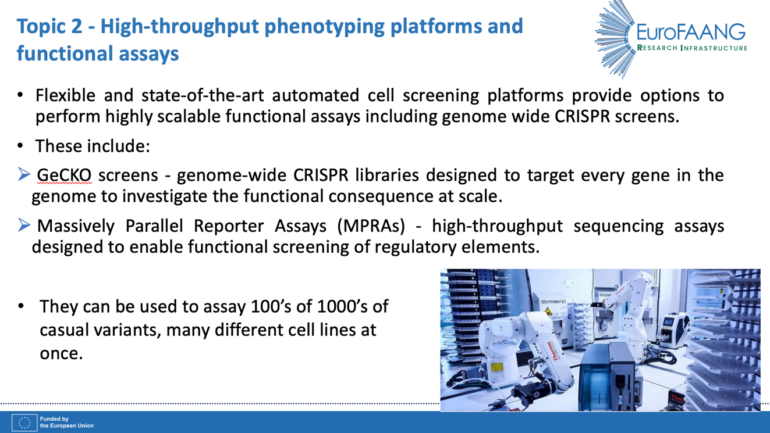

Figure 2A: First slide used to introduce the concept of high throughput cellular phenotyping platforms and CRISPR screens to the think-tank participants.

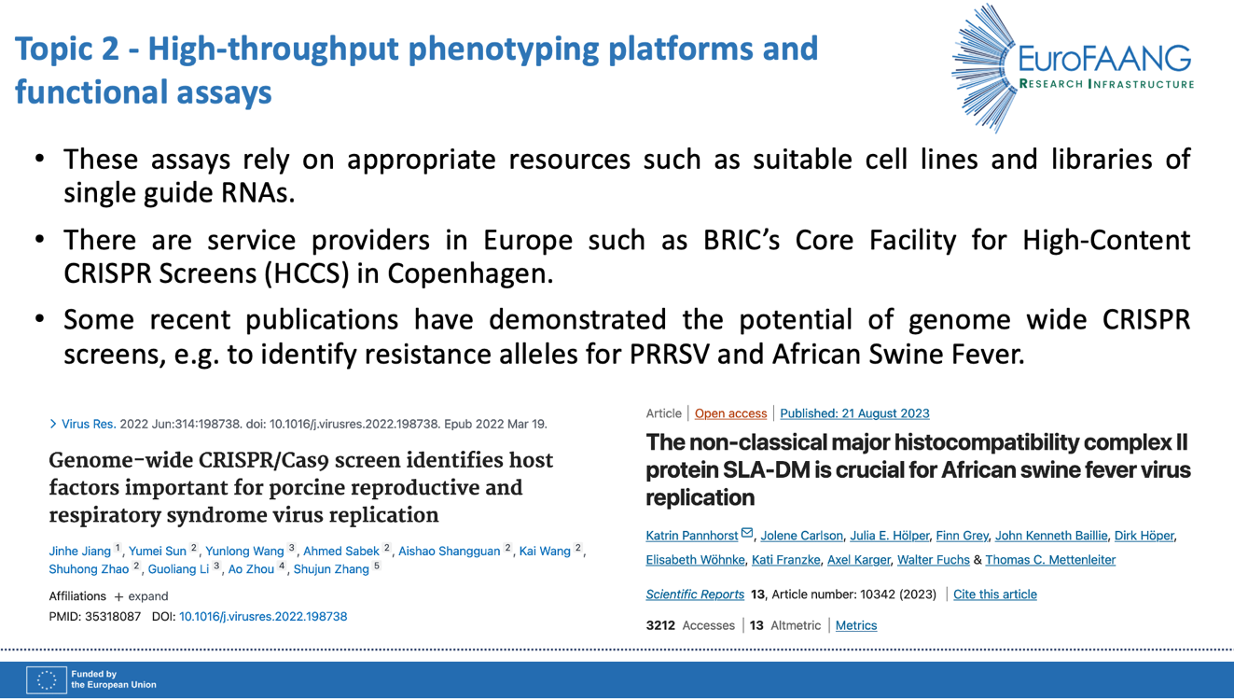

Figure 2B: Second slide used to introduce the concept of high throughput cellular phenotyping platforms and CRISPR screens to the think-tank participants.
A facilitated discussion for 45 minutes followed the introduction. The discussion focused on the opportunities, priorities and barriers associated with high throughput cellular phenotyping platforms, CRISPR screens and MPRA. Google Jamboard was used, and participants added sticky notes as comments, which are shown in Figure 3.

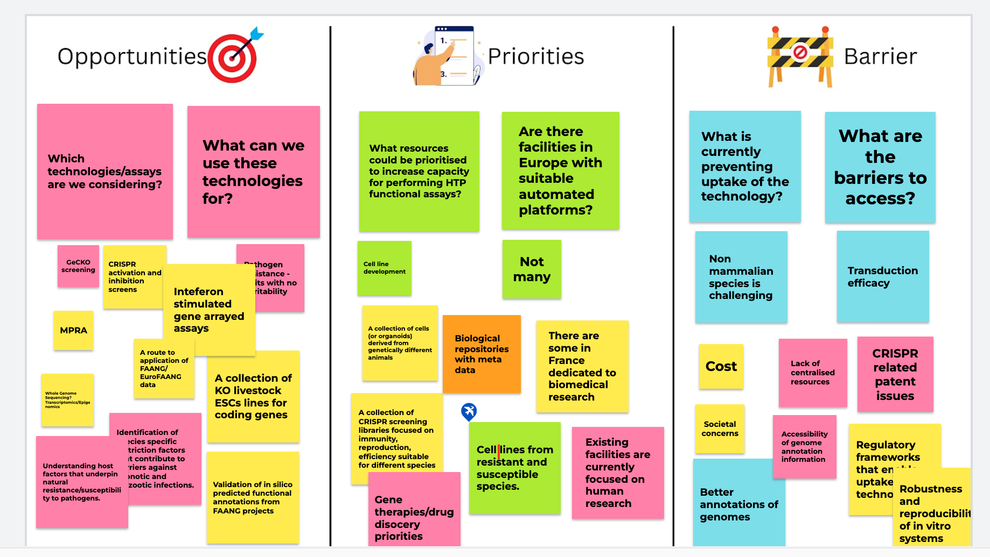

Figure 3: The Google Jamboard created by participants in the think-tank for the HTP and functional assays topic for D5.1.
During the discussion the following points were raised:

Opportunities
- Understanding host factors that underpin natural resistance and susceptibility to pathogens e.g. bacterial and viral infections.
- Identification of species-specific restriction factors that contribute to barriers against zoonotic infection.
- Development of a collection of knock-out embryonic stem cell (ESC) lines for farmed animals.
- Development of Interferon Stimulated Genes (ISG) arrayed assays for farmed animal species e.g. (11).
- Development of CRISPR activation and inactivation screens.
- A route to application of FAANG/EuroFAANG data.
- Validation in silico of functionally enriched genomic regions/variants from EuroFAANG projects.
- Cas9 expressing animals from which to make new cellular models.
- Screening for off-target effects e.g. (12).

Priorities
- Development of new cell lines for farmed animal species.
- A collection of cellular models (e.g. cell lines and organoids) derived from genetically different animals.
- A collection of CRISPR genome wide screening libraries focused on immunity, reproduction and efficiency across multiple farmed animal species.
- Expanding capacity for HTP from humans to farmed animals.
- Use of the technology for gene therapy and drug discovery.
- Primary cells from resistant and susceptible animals (e.g. birds resistant and susceptible to avian influenza) for comparative screens.

Barriers
- Work on non-mammalian species, e.g. avians, is challenging.
- CRISPR related patent issues can be restrictive particularly for industry involvement.
- Regulatory frameworks for the implementing findings are still limiting.
- Challenge experiments require category 3 laboratories which are limited in capacity across Europe (many are saturated with work).
- Poor genome annotation, for some species, particularly of immune genes, which are difficult to annotate accurately.
- Lack of accessibility to genome annotation information, more training required.
- Lack of suitable well characterised cell lines and cellular systems e.g. organoids.
- Capacity for performing high-throughput cellular phenotyping in Europe is limited and focused on human research.
- Lack of training and expertise in sgRNA design.

EuroFAANG RI WP5 Webinar on “The Power of G2P Research in Farmed Animals through High-Throughput CRISPR Screens”

Following the 2nd Think-Tank meeting, UEDIN and EFFAB arranged a webinar entitled “The Power of G2P Research in Farmed Animals through High-Throughput CRISPR Screens.” which was given by one of the Think-Tank participants Dr Finn Grey from the Roslin Institute, University of Edinburgh, on the 24th of May 2024. In total 91 people registered for the webinar. A recording is available on the EuroFAANG website (https://eurofaang.eu/video/). During the webinar Dr Finn Grey described his recent published research, in collaboration with FLI in Germany, using genome wide CRISPR screens to identify genes associated with resistance to African Swine Fever Virus (ASFV) in porcine cells (7). He described different methods of lentiviral transduction, sgRNA library design and further potential applications of the technology. In a short discussion following the webinar subjects including, sharing the sgRNA libraries via the FAANG data portal to minimise duplicated effort, current challenges and priorities (e.g. avian influenza), the diversity of libraries available across species and the potential for collaboration via the EuroFAANG RI project were covered. Finn Grey (UEDIN) also described some of the current limitations of using in vitro cellular models including difficulties with efficient delivery of sgRNAs to organoids, and the potential of the Cas9 expressing chicken and pig models as resources to overcome these issues (13).

WP4 workshop session to build expertise in single guide RNA design
During the genome editing think-tank discussion a lack of expertise in sgRNA design was identified as a barrier to using the technology. To build expertise in the design of sgRNA CRISPR libraries Finn Grey (UEDIN) will give a seminar and training session at the workshop “G2P in a Dish: A workshop on genotype to phenotype research in domestic animals: in vitro models and standards” https://eurofaang.eu/g2p-in-a-dish/ organised by INRAE and WUR for WP4. The workshop will take place in February 2025. Various tools exist for sgRNA design e.g. (14) and Finn Grey will cover optimisation of library design and application in his two hour interactive session that will be delivered in person. He will also give a seminar during the workshop ahead of the session.

Facilities with ‘High-throughput cell phenotyping platforms’ within Europe
One of the key components that is required to make genome wide CRISPR screens scalable, to screen 100’s of 1000’s of alleles in multiple cell lines at once, is the ability to perform high-throughput cellular phenotyping at scale, using automated and/or robotic platforms.

D5.1 UEDIN performed a search of high throughput cellular screening platform facilities in Europe. Prior to starting this activity, from discussions with participants in the think-tank, it was clear that there were only a small number of facilties in Europe with this capacity and many were focused on human research. The facilities identified are shown in Table 1 and summarised below.

Table 1: List of examples of high throughput cellular screening platform facilities in Europe with capacity to perform CRISPR screens at scale

Country | Facility | Webpage
France | IGBMC - high throughput cell screening platform | https://www.igbmc.fr/en/plateforms-and-services/platforms/high-throughput-cell-screening
Denmark | BRIC - Core Facility for High-Content CRISPR Screens (HCCS) | https://www.bric.ku.dk/core-facilities/high-content-crispr-screens-hccs/
United Kingdom | University of Cambridge/AstraZeneca - Functional Genomics Screening Laboratory | https://ncats.nih.gov/research/research-activities/functional-genomics-lab
Germany | Max Planck Institute – CRISPR Screening Core Facility | https://www.age.mpg.de/crispr-screening

More details of each of these facilities are included below:

France

The Institute of Genetics and Molecular and Cellular Biology (IGBMC) has a high throughput cell screening platform, at the Illkirch-Graffenstaden Innovation Park in Strasbourg. This platform provides researchers with an infrastructure for high cell content analysis and a global solution for loss/gain of function genetic screens. Services are primarily focused medical research and on human and mouse models.

The services they provide are:
- The development of cellular tests
- The development of methods for analysing cellular phenotypes
- HCS/HTS screening of siRNA libraries (kinome to genome) on mammalian cells
- Positive and negative selection screening of pan-genomic CRISPR-Cas9 lentiviral libraries (KO, activation, repression) in mammalian cells
- HCS/HTS screening of chemical molecules in mammalian cells
More details are available via their webpages:

https://www.igbmc.fr/en/plateforms-and-services/platforms/high-throughput-cell-screening

Denmark
The Biotech Research and Innovation Centre (BRIC), within the University of Copenhagen has a Core Facility for High-Content CRISPR Screens (HCCS) that offers assay automation and cell-based screening to BRIC, the University of Copenhagen and external researchers. Their flexible and state-of-the-art screening platform provides a wide variety of automated assays for human research projects.
Customized screens that can be performed in 96-and 384-well microtitre plate format utilize immunofluorescence/fluorescent markers, luminescence or qPCR as readout. They offer customized screening plates from a genome wide single guide RNA (sgRNA) CRISPR library and have several human siRNA libraries readily available.
More details are available on their webpages:
https://www.bric.ku.dk/core-facilities/high-content-crispr-screens-hccs/
They also provide a comprehensive set of pricing which is useful for the EuroFAANG RI project for defining units of access for building similar capacity in farmed animals.
https://www.bric.ku.dk/core-facilities/high-content-crispr-screens-hccs/prices/
The list of instruments within the facility at BRIC (Figure 1) is also useful for determining an access framework for building similar capacity for farmed animals for the EuroFAANG RI project:
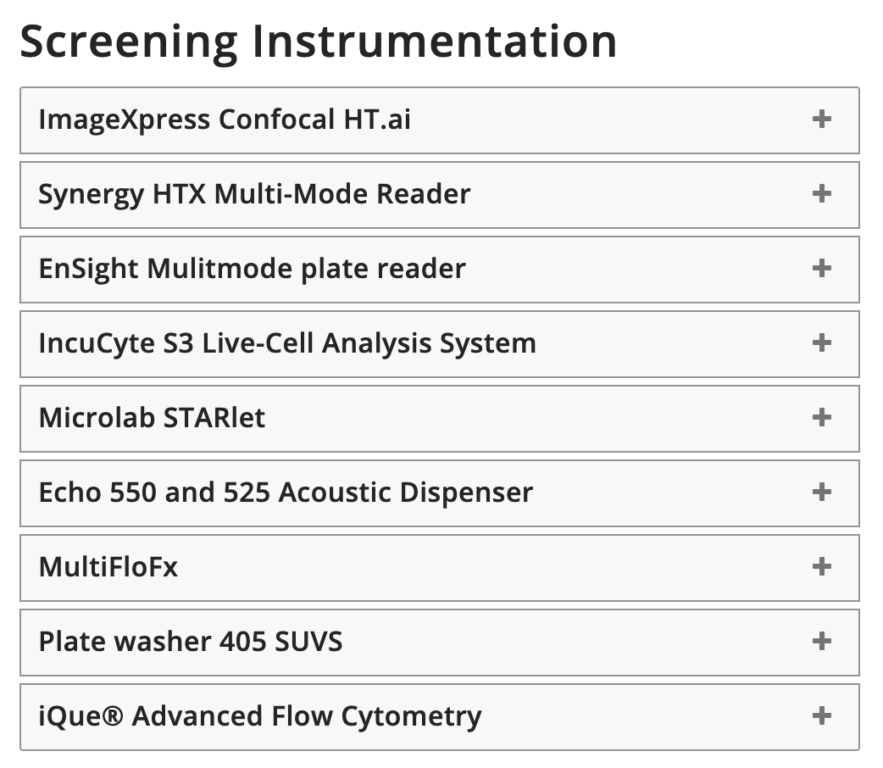
Figure 1: List of instruments available at BRICs Core Facility for High-Content CRISPR Screens (HCCS) from https://www.bric.ku.dk/core-facilities/high-content-crispr-screens-hccs/instruments/

United Kingdom

The UK capacity for high-throughput phenotyping and CRISPR screens is also currently focused on the human research space. Recently, AstraZeneca established a new world-class functional genomics laboratory with Medical Research Council and the Milner Therapeutics Institute at the University of Cambridge. According to the press release (links below) this new facility, called the Functional Genomics Screening Laboratory, will provide researchers from across the UK with access to large-scale biological and technological tools and house an advanced automated arrayed-CRISPR screening platform. Using these tools, such as CRISPR gene editing at scale will provide insight into the relationship between genes and disease and provide new opportunities to develop therapies for chronic diseases including cardiovascular, respiratory and metabolic disease.

More information can be accessed via these links:

https://ncats.nih.gov/research/research-activities/functional-genomics-lab

https://www.astrazeneca.com/media-centre/medical-releases/astrazeneca-establishes-new-world-class-functional-genomics-laboratory-with-medical-research-council-and-the-milner-therapeutics-institute-at-the-university-of-cambridge.html

UKRI currently has an open funding call for UK researchers to collaborate with the functional genomics screening laboratory:

https://www.ukri.org/opportunity/collaborate-with-the-functional-genomics-screening-laboratory/?utm_medium=email&utm_source=govdelivery

Germany

The CRISPR screening core facility at the Max Planck Institute, for the Biology of Aging, in Germany provides access to a state-of-the-art functional genomic screening platform using CRISPR-Cas9. It trains researchers in screening approaches, guides them through screen design, and provides detailed protocols for all aspects of the screening process.

The goal of the facility is to enable researchers to perform high-quality CRISPR-Cas9 screening without the need to establish the technique themselves. As such, the core facility provides detailed training for the following screening steps:

- Optimising lentiviral transduction conditions
- determining antibiotic selection conditions
- evaluating screen treatments
- generating/validating Cas9-expressing cell lines (optional, dependent on choice of screening library)
- optimising screen readout
- bulk screen execution
- processing of samples for next-generation sequencing.

The facility if focused on research in human aging, more details are available via this link: https://www.age.mpg.de/crispr-screening

Extending HTP capacity from human research to G2P research in farmed animals
Extending capacity from the human research space to G2P research in farmed animals can be explored through the EuroFAANG RI project. These discussions will take place over the next 18 months of the EuroFAANG RI project and we will update D5.1 accordingly.

Additional service provision relevant to high-throughput cellular phenotyping

Commercial automated cell phenotyping systems
To explore commercial service provision in this space UEDIN met with Aixtron Ltd, who provide automated cell culture systems including Aixcell. Aixcell is a smart, cell culture system, which can simultaneously handle up to 200 different cell lines, or 200 different workflows. With an inbuilt microscope the system can objectively track confluence and count cells, use imaging to provide phenotype measurements and reproducibly passage and seed cells.
The Aixcell system provides the potential to perform:
- Moderate scale iPSC reprogramming or differentiation (e.g. 1-100 plates)
- Making stable cell lines (transfection, seeding at limiting dilution, isolation & expansion of clones)
- Small scale (1-1,000 plates) CRISPR screens, in e.g. 96 well plates
- Automated collection of phenotypes in the form of label-free images (phase contrast or brightfield), for ‘phase-visible phenotypes’, e.g. a proliferation assay, or a phenotype that has a morphological or phase-visible component.

Assembly of DNA constructs at scale for CRISPR screens

The Genome Foundry at the University of Edinburgh is an engineering biology research facility specialising in the modular, automated assembly of DNA constructs (https://www.ed.ac.uk/biology/research/facilities/edinburgh-genome-foundry). It has highly modulated robotic platforms that are currently used for developing gene therapies, vaccines and personalized medicine. These platforms could be adapted to generate single guide RNAs at scale to screen hundreds of thousands of causal variants from farmed animals, through precision design and implementation of highly automated CRISPR screens. UEDIN is working with the Genome Foundry on a workflow and access framework describing functionality and a model for transnational access for sgRNA synthesis. This will be added to D5.1 in the next 18 months. Currently the facility can be accessed for a fee by both University of Edinburgh and external users.

An access framework for high-throughput cellular phenotyping and CRISPR screens
Based on the outcomes of the activities described above UEDIN put together a hypothetical access request example to the EuroFAANG RI to identify resistance alleles for a viral pathogen using high-throughput CRISPR screens (Figure 4). This concept was presented at the EuroFAANG global networking event at the PAG conference in San Diego in January 2024 (D8.1), the AGBT-Ag meeting in Phoenix in April 2024 and also in the introduction to EuroFAANG ahead of the webinar given by Hao Cheng at UCDavis for WP6 on using encryption to share data between industry and academic partners.

The concept is based on a researcher who is focused on swine research and has access to a pathogen e.g. ASFV and suitable facilities to perform infections. The researcher doesn’t however have access to suitable in vitro cellular models (WP4) and sgRNA libraries (WP5) to perform genome wide CRISPR screens to identify resistance alleles and would make requests to the EuroFAANG RI to access these. They would also potentially need to access automated (high throughput) cell phenotyping platforms for which additional capacity for farm animals for which through work in D5.1 we have determine additional capacity is required. Sequencing services to generate read outs could be provided by a commercial provider or another infrastructure, such as EASIGenomics, and the data (e.g. from the H2020 GENE-SWitCH project) could be curated and interrogated via the FAANG/EuroFAANG data portal via EMBL-EBI (WP3).

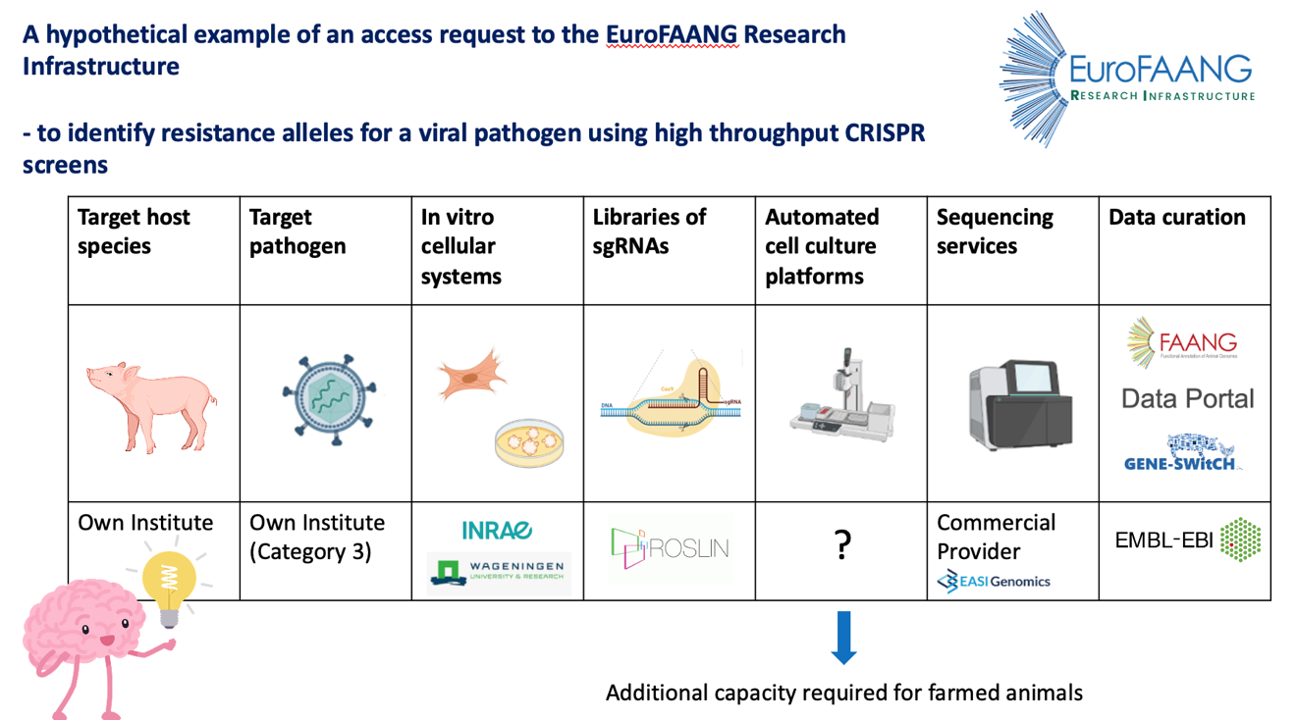

Figure 4: A hypothetical example of an access request to the EuroFAANG research infrastructure to identify resistance alleles for a viral pathogen using high-throughput CRISPR screens and high-throughput cellular phenotyping.

Conclusions
CRISPR screens, functional assays such as MPRA, and high-throughput cellular phenotyping platforms provide tools that are beyond the state of the art for genotype-to-phenotype research in farmed animals. They have potential to inform farmed animal breeding in Europe through identifying functional genetic variation e.g. resistance alleles to viral pathogens, that can be harnessed in breeding programmes, and for the discovery of new targets for genome editing, to improve animal health, welfare and productivity.

In Deliverable 5.1, through the European Think-Tank on genome editing, UEDIN and EFFAB identified the main opportunities, priorities and barriers to applying these technologies. We were also able to build collaboration and raise awareness of the potential of the technologies for G2P research in farmed animals via a webinar given by an expert in the field from UEDIN.

One of the current barriers to genome editing in farmed animals more broadly is a lack of suitable targets to edit (15,16). Using CRISPR screens to identify new genome editing targets shows considerable promise for diseases that are putting significant pressure on farmed animal breeding in Europe e.g. African Swine Fever (7).

A lack of suitable cell lines and organoid systems has hindered progress, but this is rapidly changing, particularly with the generation of Cas9 expressing chickens and pigs (13). Work package 4 of the EuroFAANG RI project will address this and look at ways to build capacity and TNA to appropriate cellular models for CRISPR screens.

As more sgRNA libraries become available across farmed animal species e.g. (11,17) providing catalogues of these libraries on the FAANG data portal will be an important resource for the community and UEDIN will explore how this can be achieved with EMBL-EBI (WP3).

Building additional scale and capacity for CRISPR screens using high-throughput cellular phenotyping platforms will provide unprecedented power for G2P research in farmed animals, going beyond the state of the art. Through targeted searching and EuroFAANG networks we identified several facilities in Europe with capacity to perform high-throughput cellular phenotyping platforms though all were currently focused on the human research space. Over the next 18 months we will open a dialogue with these facilities to build capacity for farmed animals and with update this deliverable with the outcomes.

References
1. Clark EL, Archibald AL, Daetwyler HD, Groenen MAM, Harrison PW, Houston RD, et al. From FAANG to fork: application of highly annotated genomes to improve farmed animal production. Genome Biol. 2020;21(1):285.
2. le Sage C, Lawo S, Cross BCS. CRISPR: A Screener’s Guide. SLAS Discov Adv Life Sci R D. 2020 Mar;25(3):233–40.
3. Bock C, Datlinger P, Chardon F, Coelho MA, Dong MB, Lawson KA, et al. High-content CRISPR screening. Nat Rev Methods Primer. 2022;2(1):8.
4. Sun L, Zhao C, Fu Z, Fu Y, Su Z, Li Y, et al. Genome-scale CRISPR screen identifies TMEM41B as a multi-function host factor required for coronavirus replication. PLOS Pathog. 2021 Dec 6;17(12):e1010113.
5. Tse LV, Meganck RM, Araba KC, Yount BL, Shaffer KM, Hou YJ, et al. Genomewide CRISPR knockout screen identified PLAC8 as an essential factor for SADS-CoVs infection. Proc Natl Acad Sci. 2022 May 3;119(18):e2118126119.
6. Clark T, Waller MA, Loo L, Moreno CL, Denes CE, Neely GG. CRISPR activation screens: navigating technologies and applications. Trends Biotechnol; Available from: https://doi.org/10.1016/j.tibtech.2024.02.007
7. Pannhorst K, Carlson J, Hölper JE, Grey F, Baillie JK, Höper D, et al. The non-classical major histocompatibility complex II protein SLA-DM is crucial for African swine fever virus replication. Sci Rep. 2023;13(1):10342.
8. Jiang J, Sun Y, Wang Y, Sabek A, Shangguan A, Wang K, et al. Genome-wide CRISPR/Cas9 screen identifies host factors important for porcine reproductive and respiratory syndrome virus replication. Virus Res. 2022 Jun 1;314:198738.
9. Gordon MG, Inoue F, Martin B, Schubach M, Agarwal V, Whalen S, et al. lentiMPRA and MPRAflow for high-throughput functional characterization of gene regulatory elements. Nat Protoc. 2020 Aug 1;15(8):2387–412.
10. Littlejohn MD, Lopdell TJ, Trevarton A, Moody J, Tiplady KM, Burborough KA, et al. 534. A massively parallel reporter assay to screen bovine regulatory variants. In: Proceedings of 12th World Congress on Genetics Applied to Livestock Production (WCGALP). Wageningen Academic Publishers; 2022. p. 534–2216. Available from: https://doi.org/10.3920/978-90-8686-940-4_534
11. Dang W, Li T, Xu F, Wang Y, Yang F, Zheng H. Establishment of a CRISPR/Cas9 knockout library for screening type I interferon-inducible antiviral effectors in pig cells. Front Immunol. 2022;13. Available from: https://www.frontiersin.org/journals/immunology/articles/10.3389/fimmu.2022.1016545
12. Redel BK, Yoon J, Reese E, An H, Uh K, Chen PR, et al. Novel off-Targeting Events Identified after Genome Wide Analysis of CRISPR-Cas Edited Pigs. CRISPR J. 2024 Jun 1;7(3):141–9.
13. Rieblinger B, Sid H, Duda D, Bozoglu T, Klinger R, Schlickenrieder A, et al. Cas9-expressing chickens and pigs as resources for genome editing in livestock. Proc Natl Acad Sci U S A. 2021 Mar 9;118(10).
14. Vinceti A, De Lucia RR, Cremaschi P, Perron U, Karakoc E, Mauri L, et al. An interactive web application for processing, correcting, and visualizing genome-wide pooled CRISPR-Cas9 screens. Cell Rep Methods. 2023 Jan 23;3(1). Available from: https://doi.org/10.1016/j.crmeth.2022.100373
15. Clark EL. Breeding in an Era of Genome Editing BT - Encyclopedia of Sustainability Science and Technology. In: Meyers RA, editor. New York, NY: Springer New York; 2020. p. 1–16. Available from: https://doi.org/10.1007/978-1-4939-2493-6_1122-1
16. Tait-Burkard C, Doeschl-Wilson A, McGrew MJ, Archibald AL, Sang HM, Houston RD, et al. Livestock 2.0 – genome editing for fitter, healthier, and more productive farmed animals. Genome Biol. 2018;19(1):204.
17. Yu C, Zhong H, Yang X, Li G, Wu Z, Yang H. Establishment of a pig CRISPR/Cas9 knockout library for functional gene screening in pig cells. Biotechnol J. 2022 Jul;17(7):e2100408.

